|  |  |  |
| --- | --- | --- |
|  | **CMPS 312 Project Phase 1 – UI Design and Implementation**  **(20% of the course grade)** | |
| **Group Id:** | | **Project Group Members:**  **Hanan Rashid – 202006354**  **Rain Alkai – 202005090**  **Arwa Alobeid-202102413**  **Hanan Alyafei - 201808914** |
| **Group Members:** | | **Emails:** |

**Grading Rubric - In the Functionality column please specify either: *Working (completed x%)*, *Not Working (completed x%)* or *Not done*.**

|  |  |  |  |  |
| --- | --- | --- | --- | --- |
| Criteria | | % | Functionality* | Quality of the implementation |
| 1. **Application Design:** Repositories or Providers Class Diagram | | 5% |  |  |
| **2) Design and implement** | | **90%** |  |  |
|  | U1 – Login | 5 |  |  |
| U2 - YalaPay Dashboard | 5 |  |  |
| U3 - List/Search/Add/ Update and Delete a customer:  1. List Customers (5 pts)  2. Search Customers (4 pts)  3. Add Customer (6 pts)  4. Update Customer (4 pts)  5. Delete Customer (3 pts) | 22 |  |  |
| U4 - List/Search/Add/ Update and Delete an Invoice  1. List Invoices (5 pts)  2. Search Invoices (4 pts)  3. Add Invoice (6 pts)  4. Update Invoice (4 pts)  5. Delete Invoice (3 pts) | 22 |  |  |
| U5 - List/Search/Add/ Update and Delete payments for an invoice  1. List Payments (5 pts)  2. Search Payments (4 pts)  3. Add Payment (8 pts)  4. Update Payment (5 pts)  5. Delete Payment (3 pts) | 25 |  |  |
| U6 - Manage Cashing Cheques  1. Add Cheques Deposit (10 pts)  2. List Cheque Deposits (5 pts)  3. Update Cheques Deposit (15 pts) | 30 |  |  |
| U7 - Invoices Report | 8 |  |  |
| U8 - Cheques Report | 8 |  |  |
| **3) Testing documentation** using screen shots illustrating the app testing.  - Discussion of the project contribution of each team member [-10pts if not done] | | 5% |  |  |
| **Total** | | 100 |  |  |
| Copying and/or plagiarism or not being able to explain or answer questions about the implementation | | -  100 |  |  |

**\* Possible grading for functionality** - ***Working*** (get 70% of the assigned grade), ***Not*** ***working*** (lose 40% of assigned grade and ***Not done*** (get 0). The remaining grade is assigned to the quality of the implementation.

In case your implementation is not working then 40% of the grade will be lost and the remaining 60% will be determined based on of the code quality and how close your solution to the working implementation.

Solution quality also includes meaningful naming of identifiers (according to Flutter/Dart naming conventions), no redundant code, simple and efficient design, clean implementation without unnecessary files/code, use of comments where necessary, proper code formatting and indentation.

**Marks will be reduced** forcode duplication, poor/inefficient coding practices, poor naming of identifiers, unclean/untidy submission, and unnecessary complex/poor user interface design.

* **Figma:**

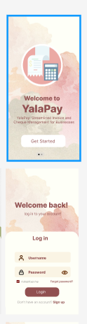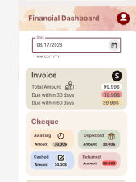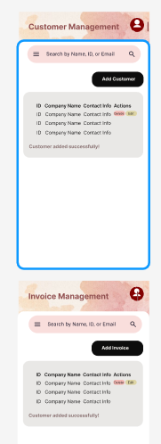

# Application Design – Repositories or Providers Class Diagram

**Repository Classes Diagram**

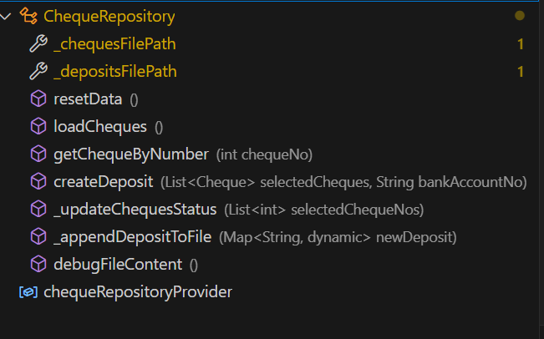

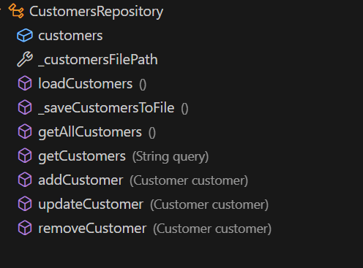

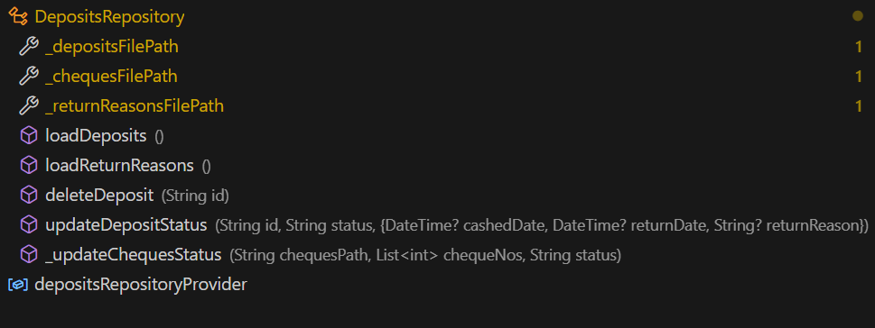

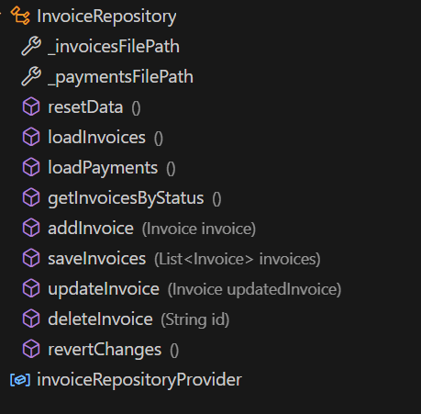

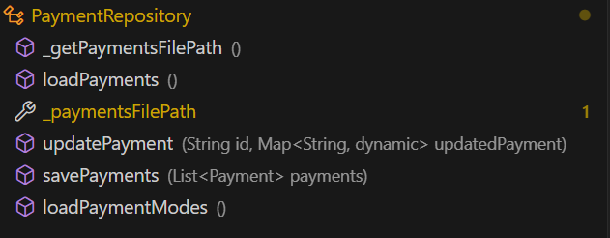

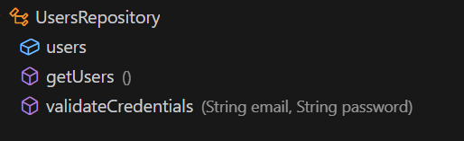

# Testing

# U1 – Login

* **Start screen:**

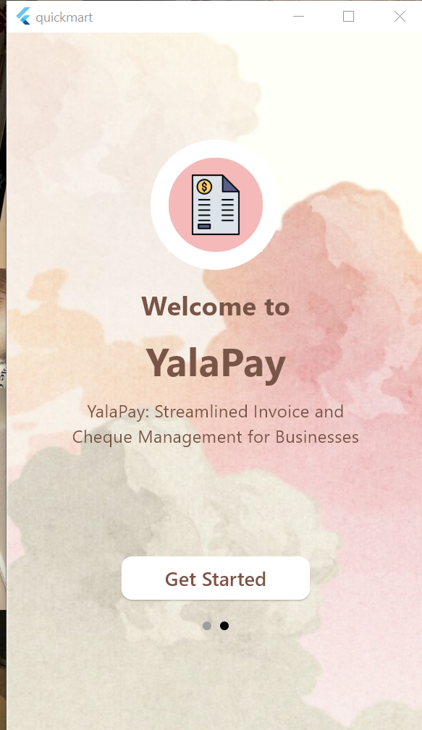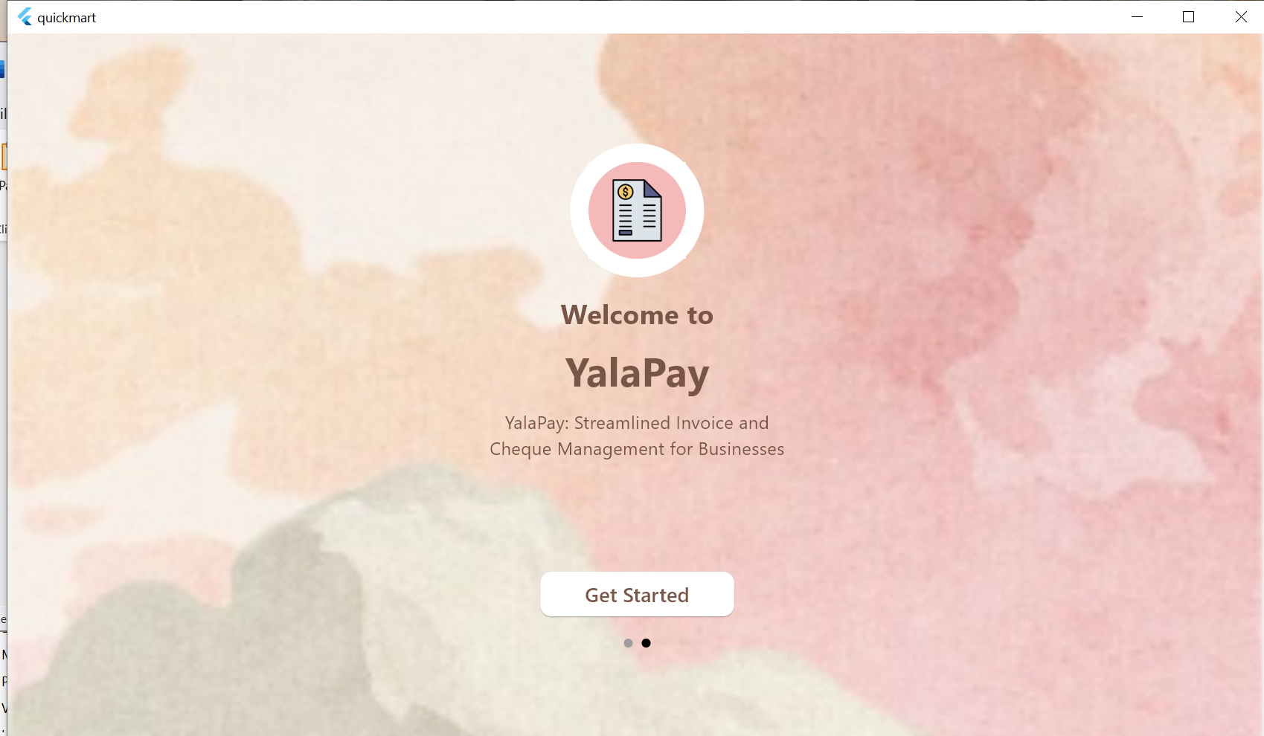

* **Login**:

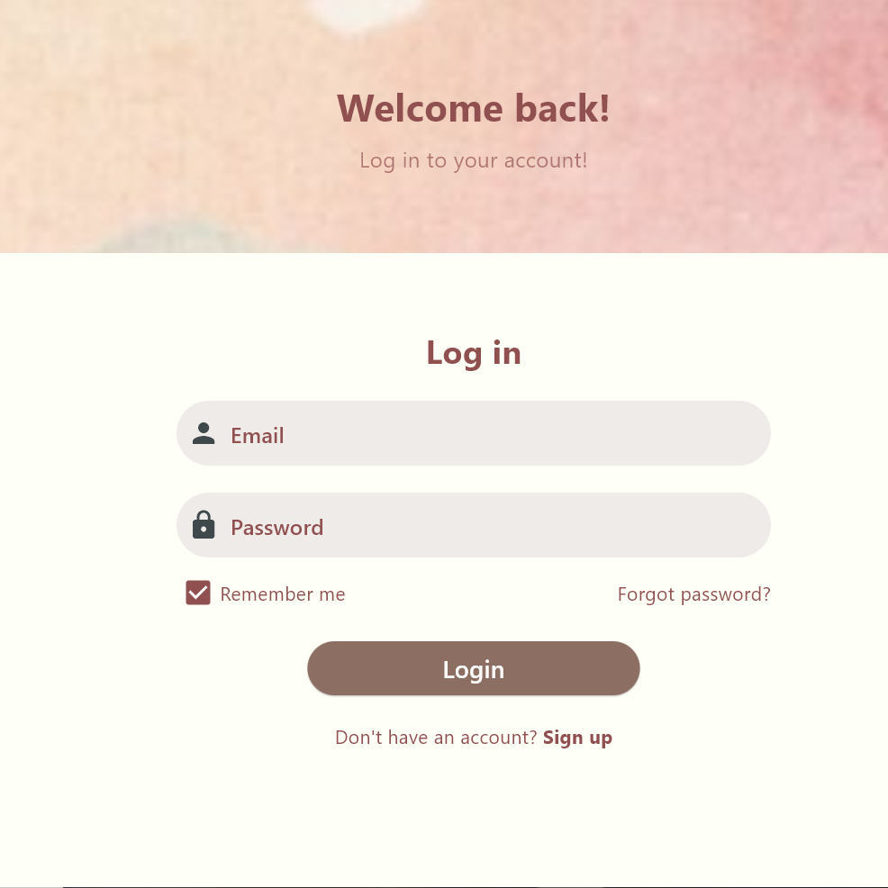

* **Incorrect validation**

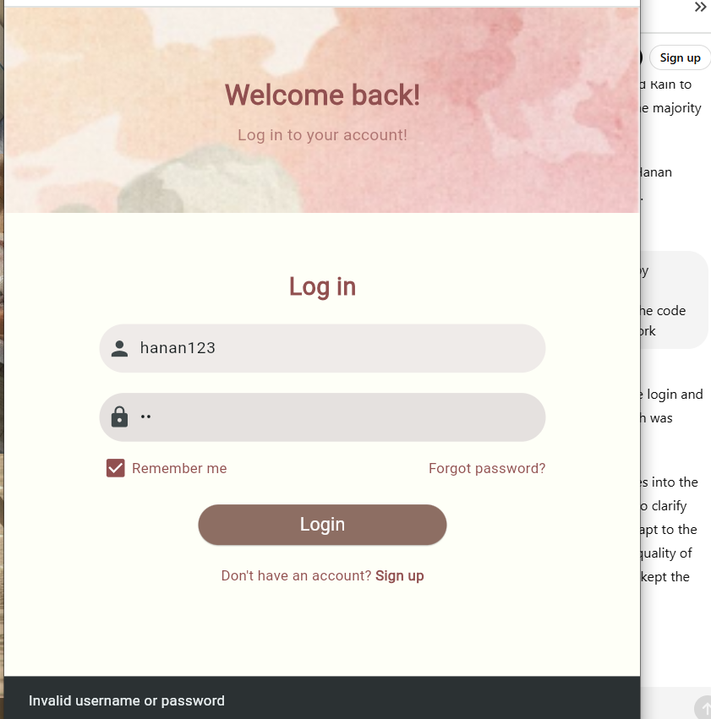

* **Correct Validation**

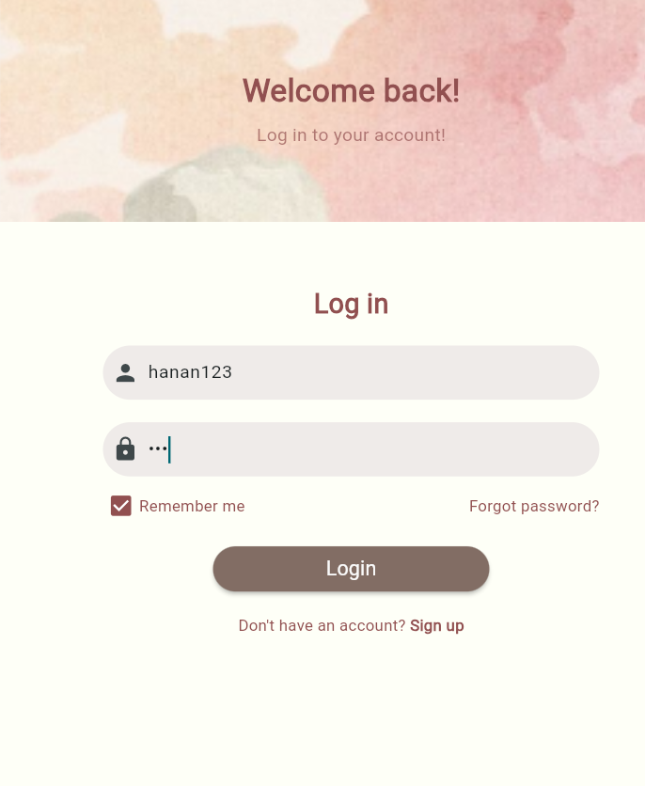

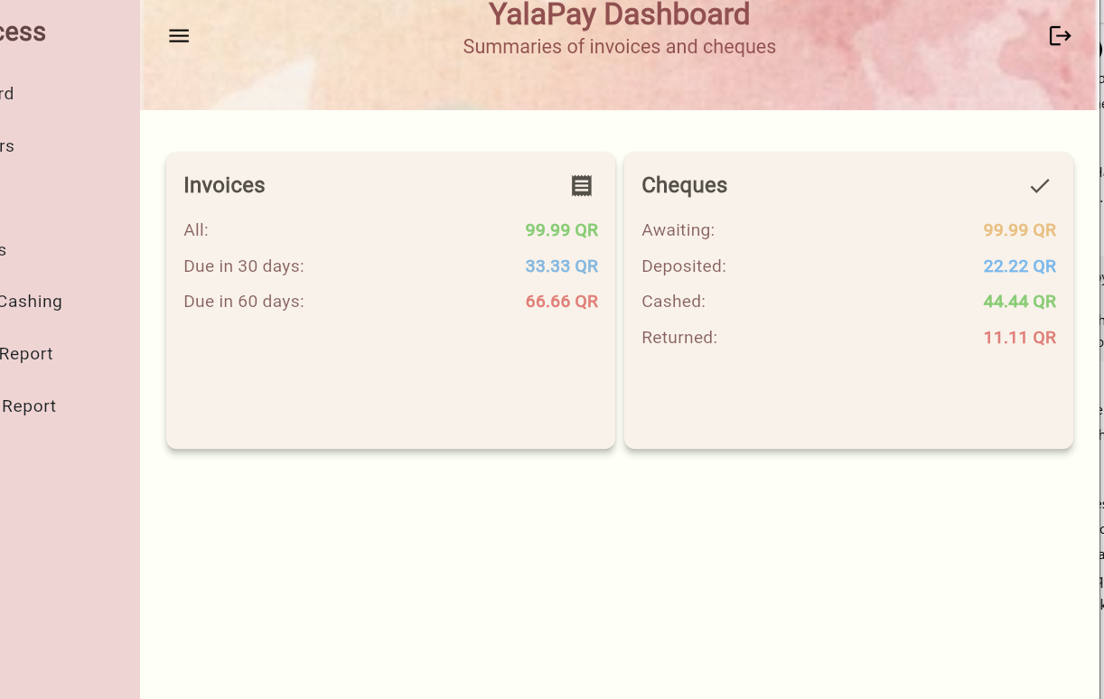

* **Logout**

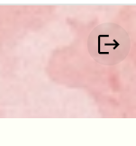

# U2 - YalaPay Dashboard

* **Dashboard (Responsive):**

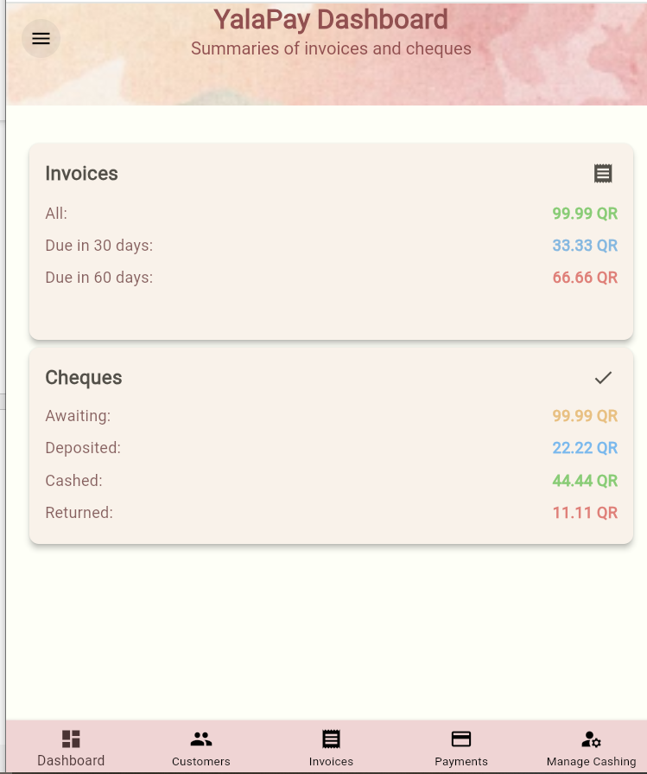

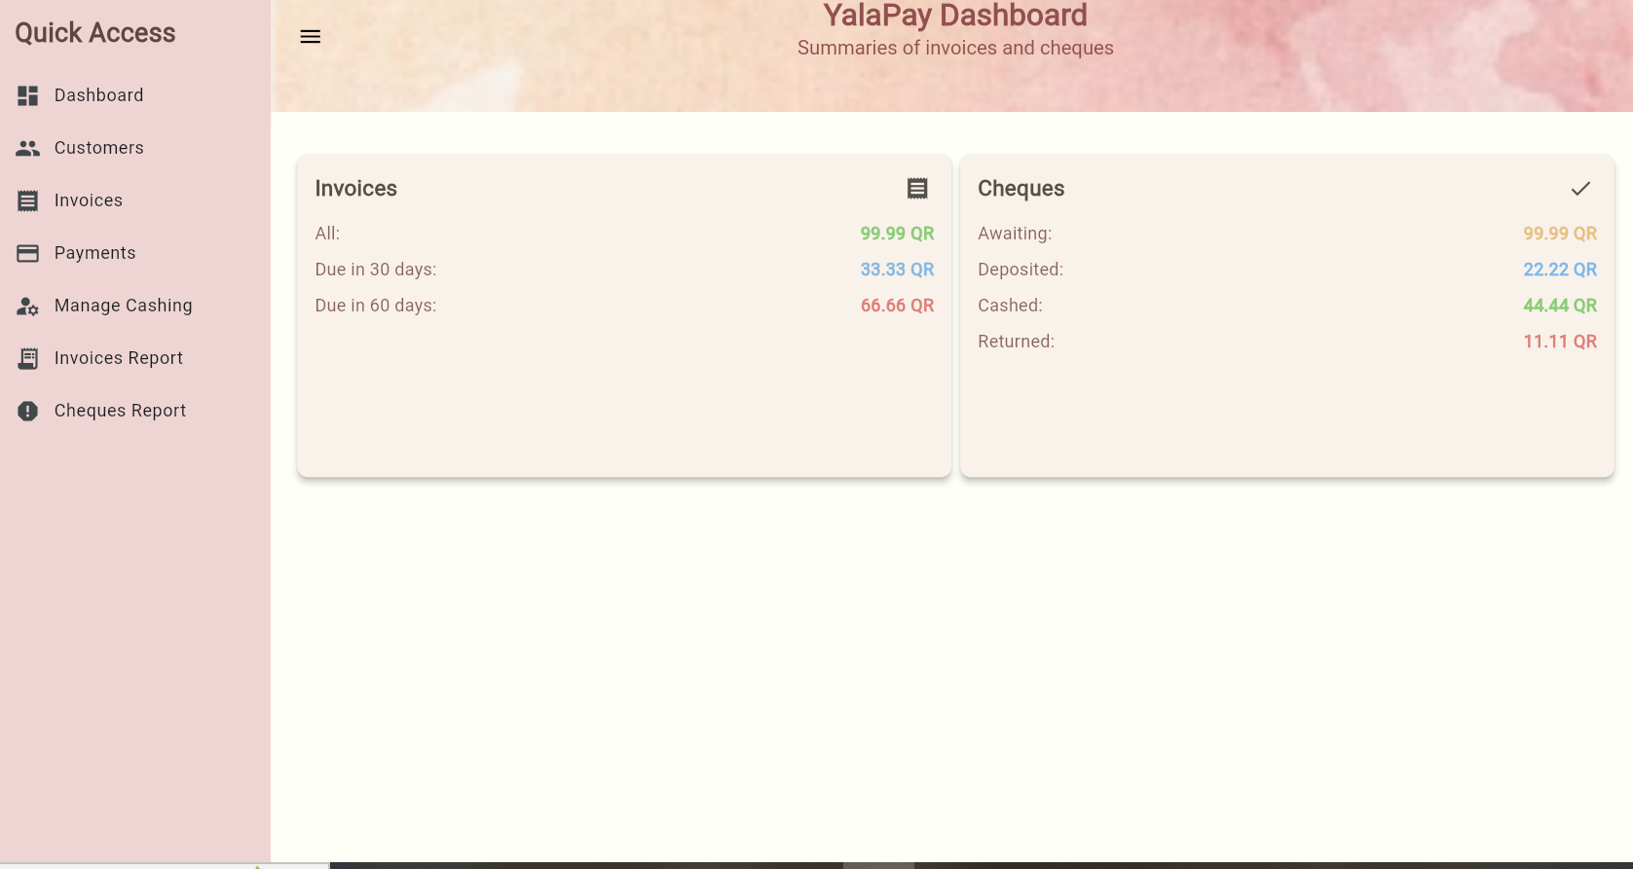

# U3 - List/Search/Add/ Update and Delete a Customer

# List Customers

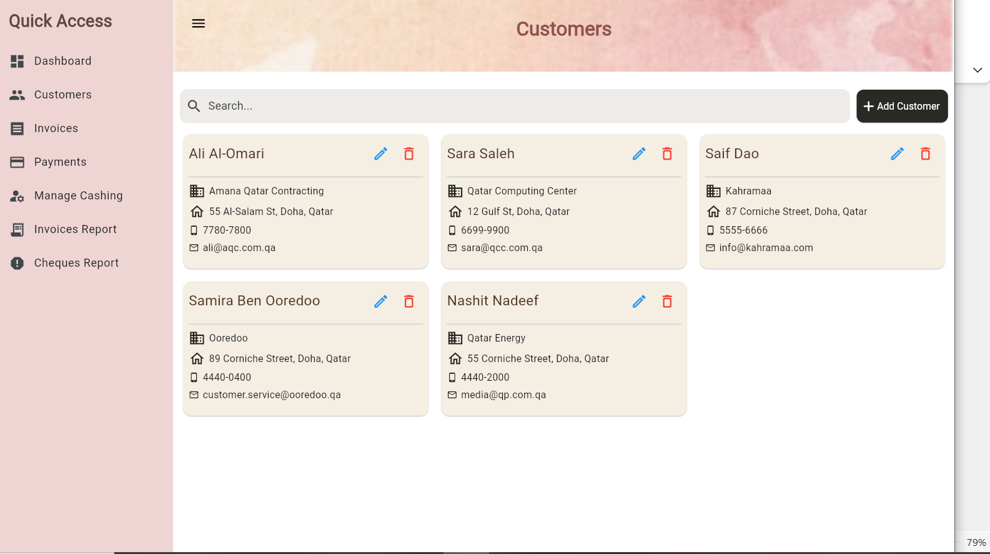

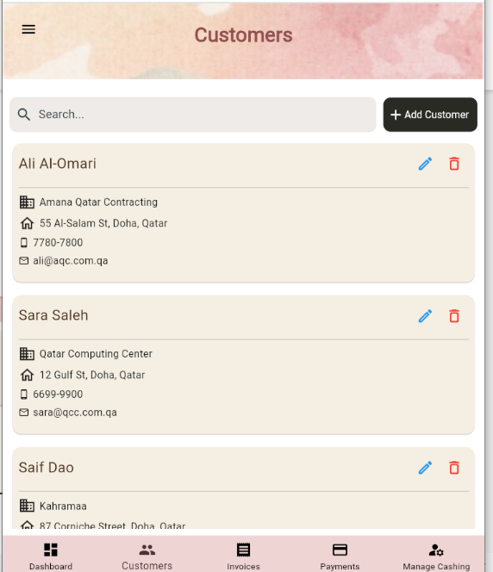

# Search Customers

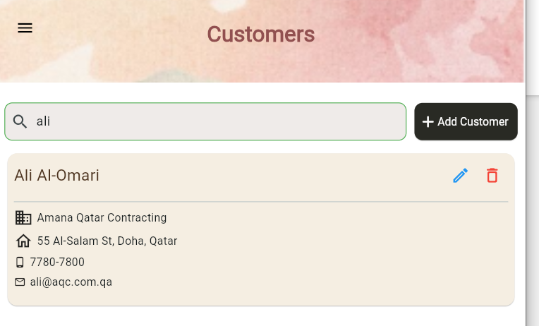

# Add Customer

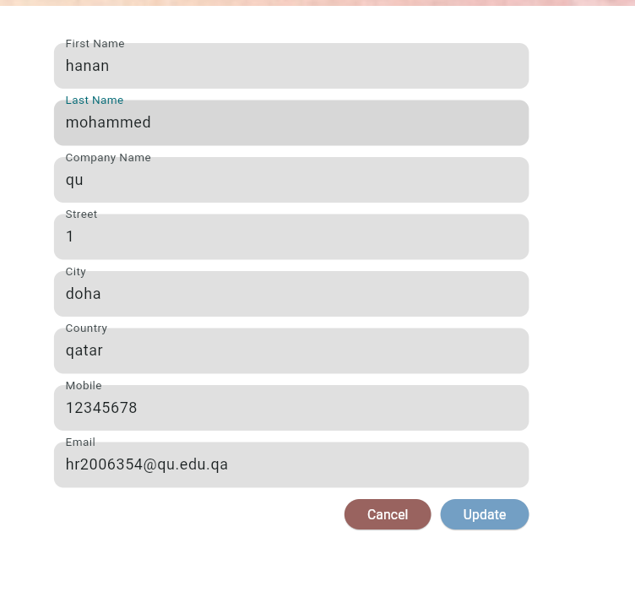

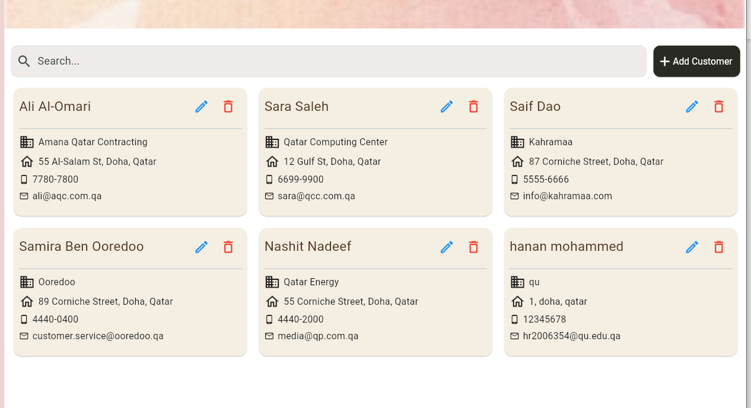

# Update Customer





# Delete Customer



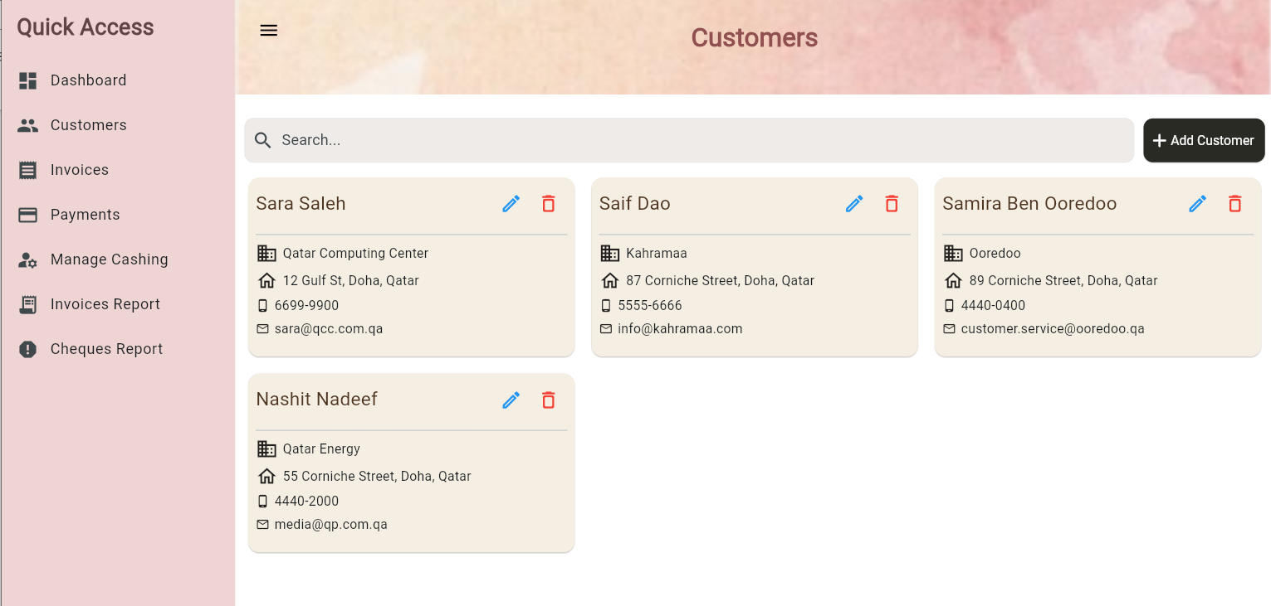

**When deleted I deletes all invoices associated with it, and payments associated with the invoices of that specific customer.**

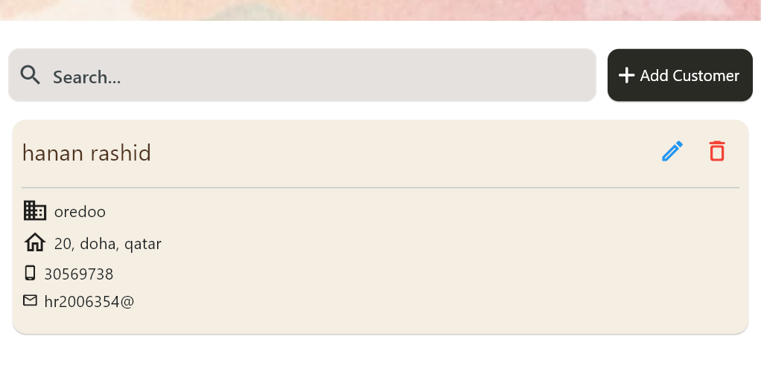

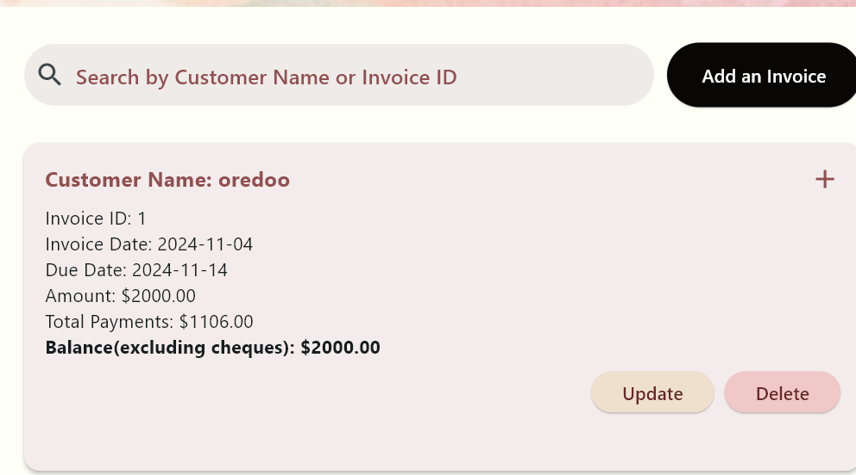

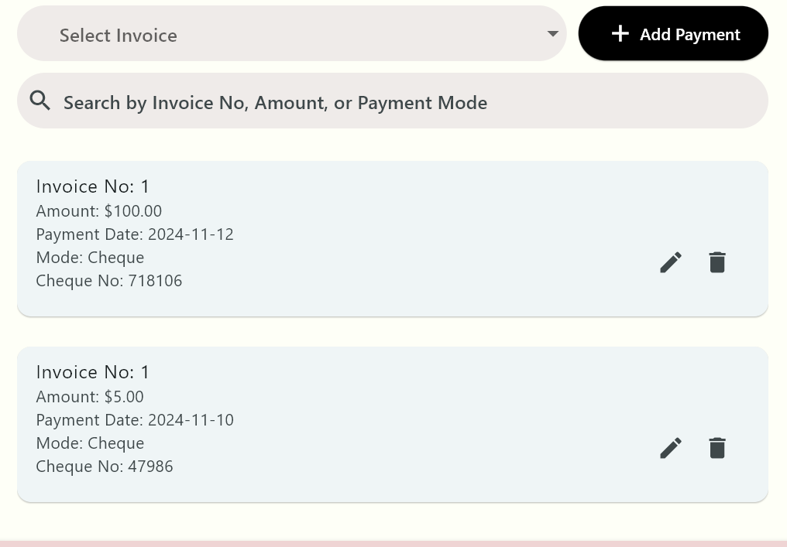

**Now Delete Customer:**

**Customer:**

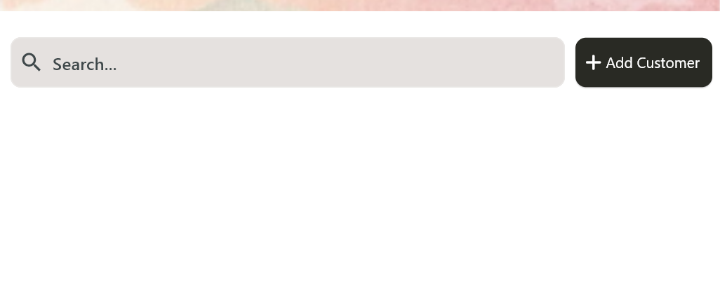

**Invoice:**

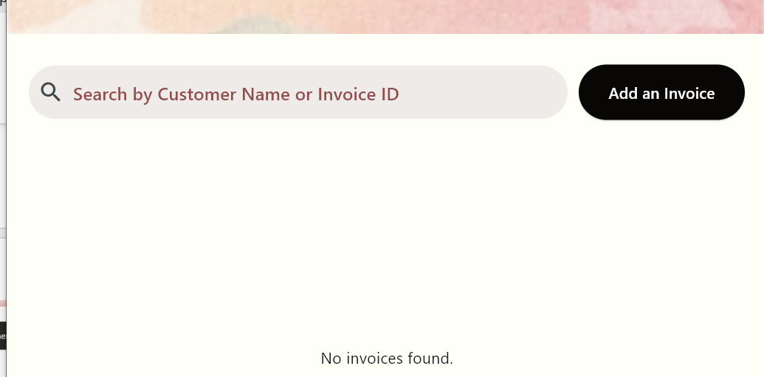

**Payment:**

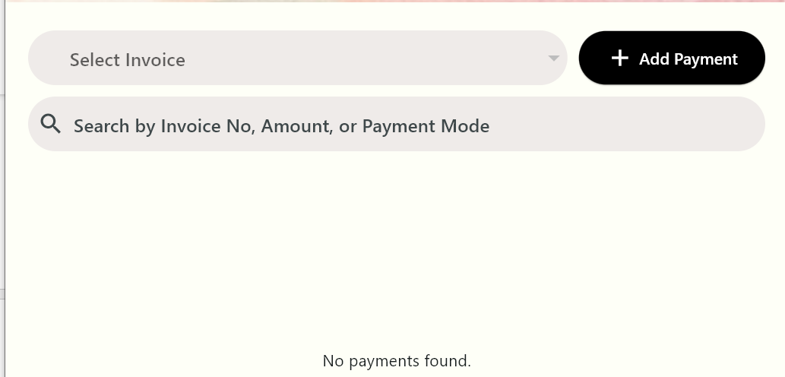

# U4 - List/Search/Add/ Update and Delete an Invoice

# List Invoices

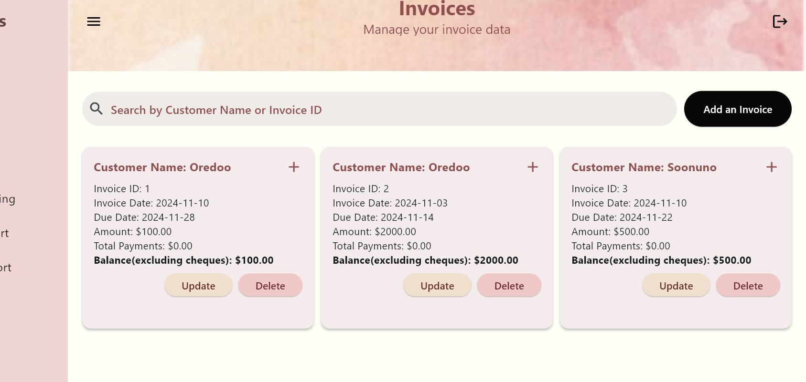

**For balance: only computes balance excluding cheques**

# Search Invoices

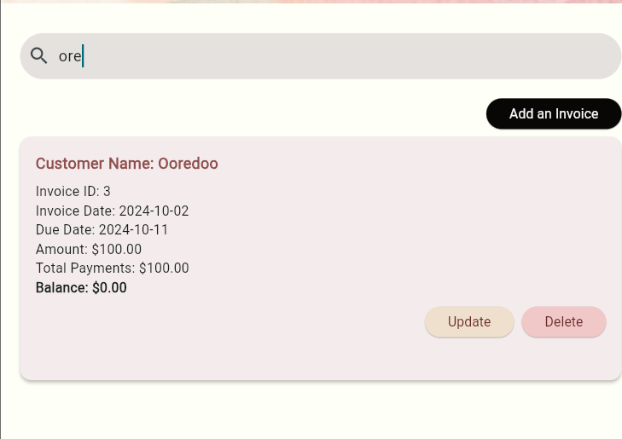

# Add Invoice

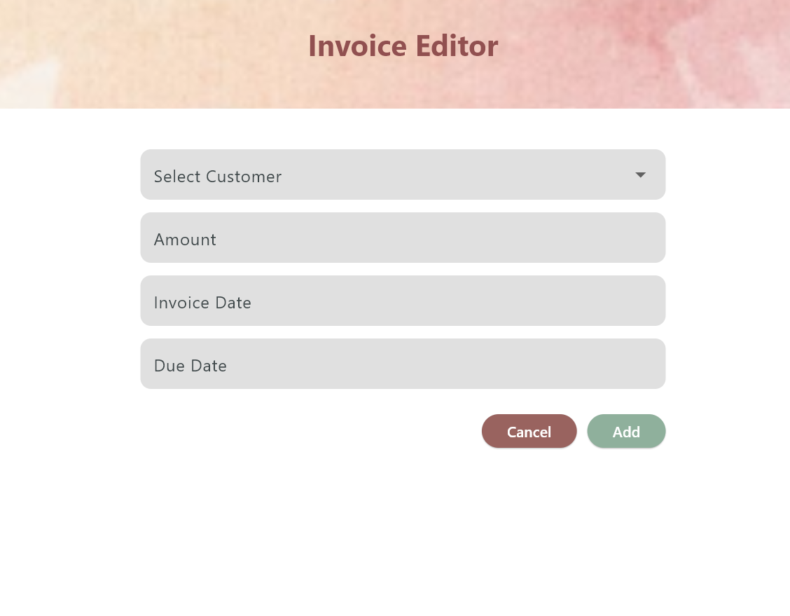

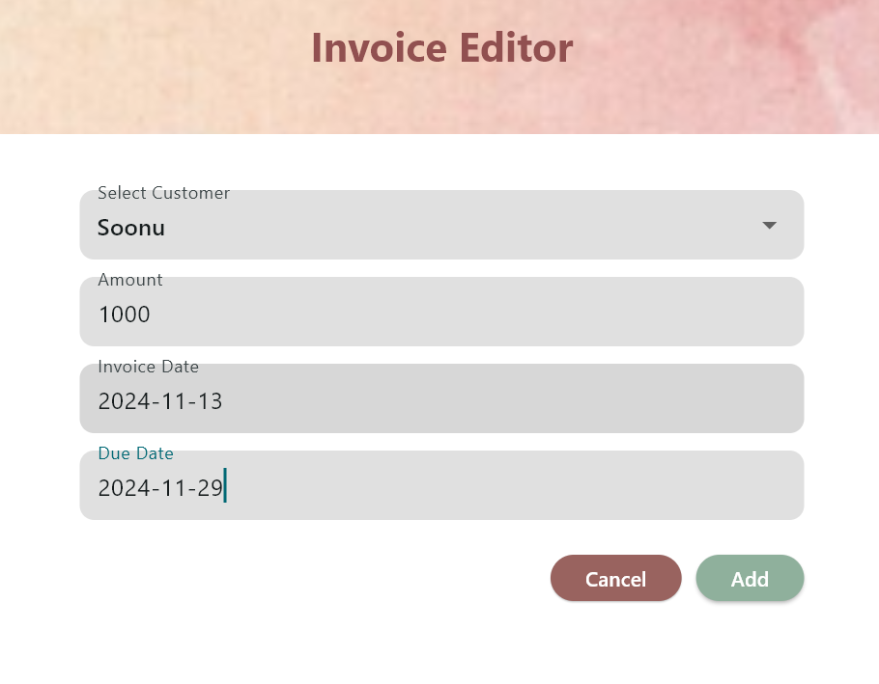

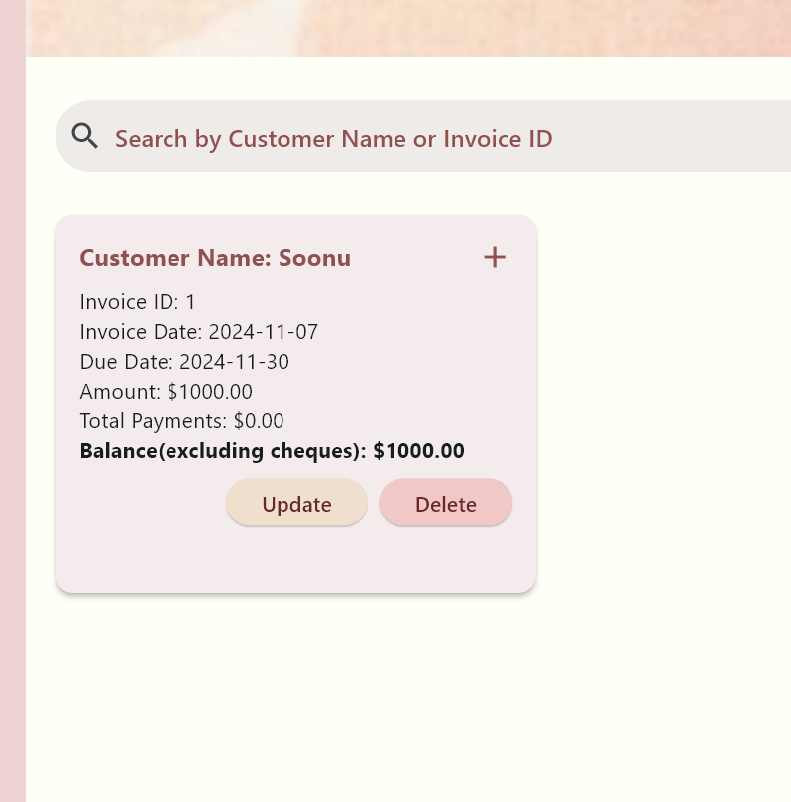

# Update Invoice

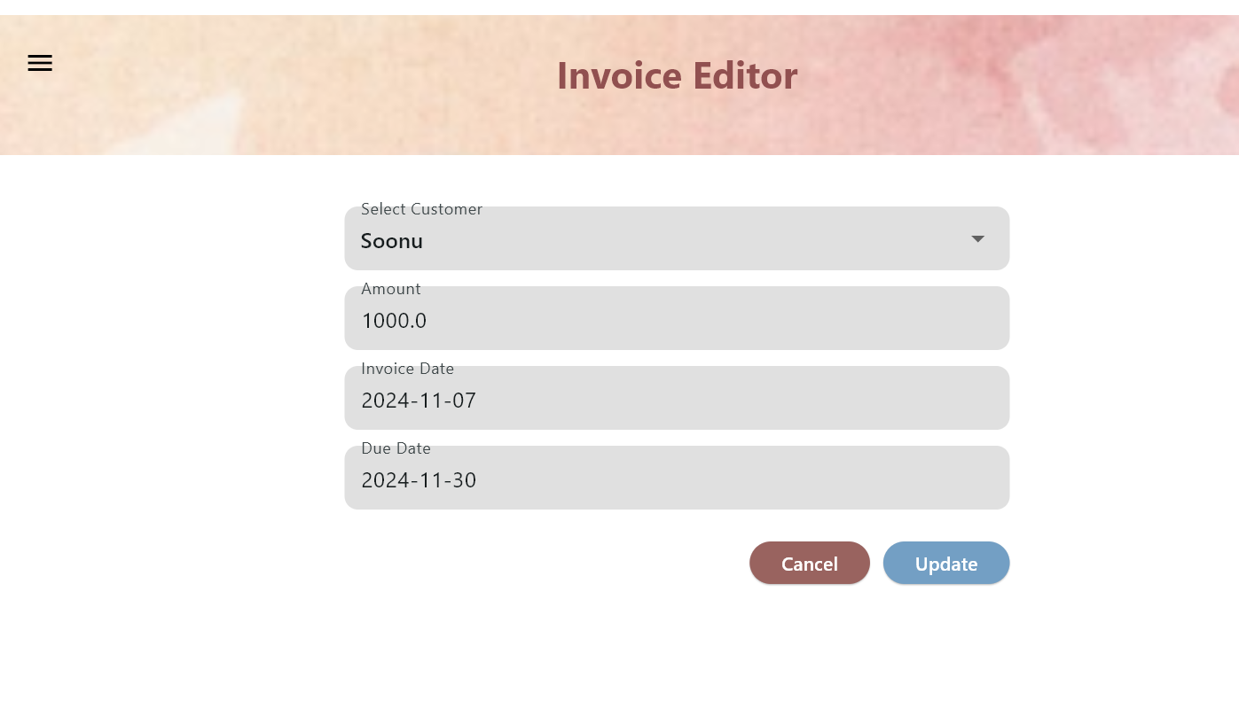

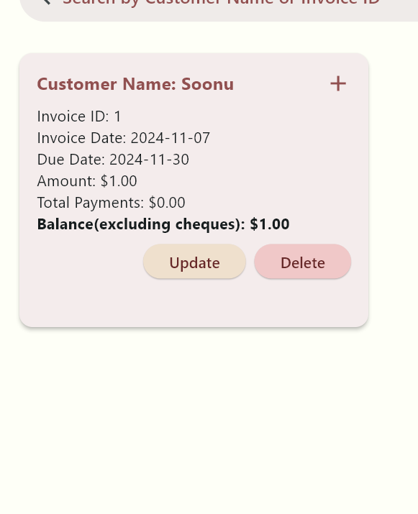

# Delete Invoice

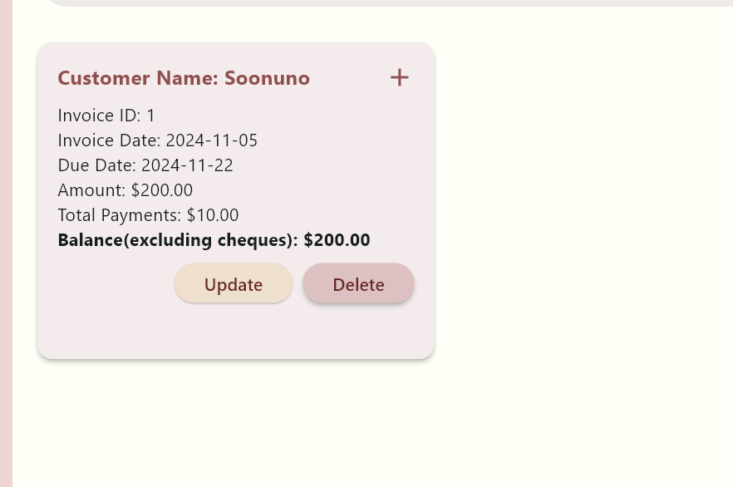

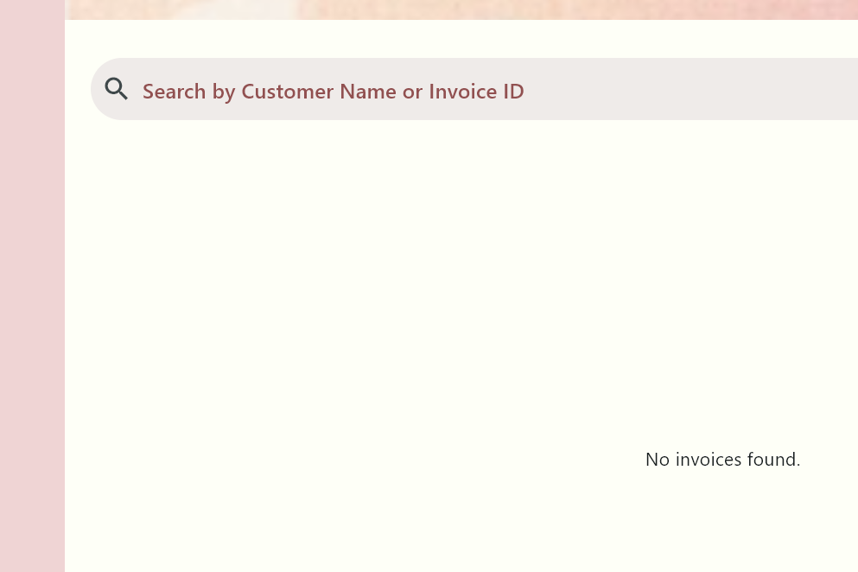

# Enter Payment For Invoice

* **- Enter Payments for Invoice: ( Without Cheque)**

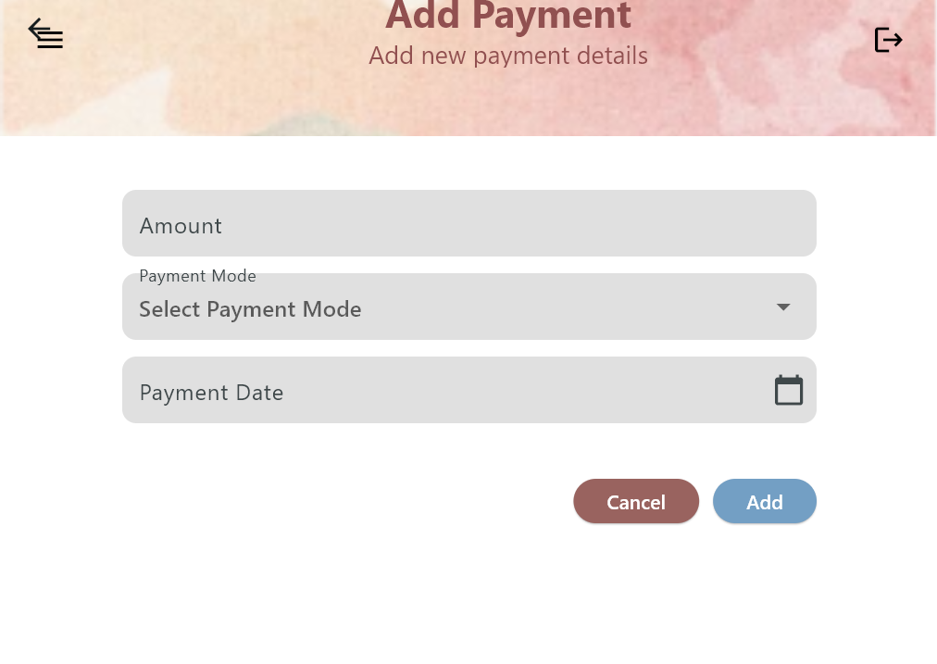

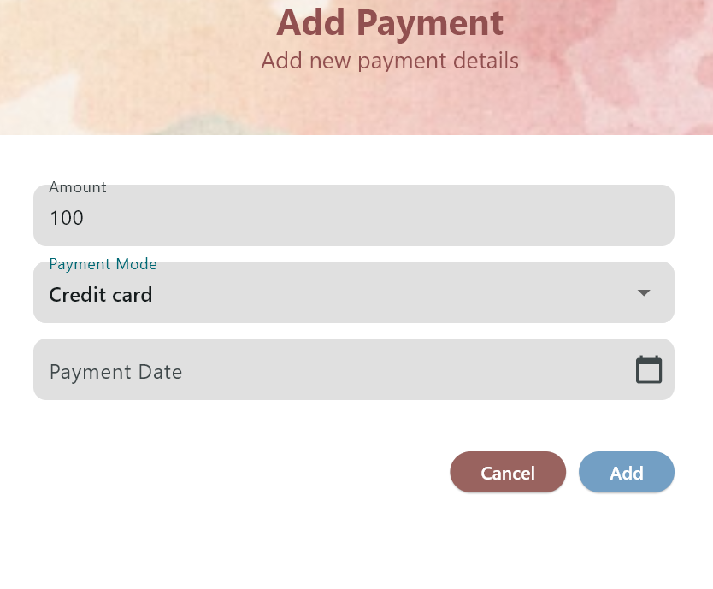

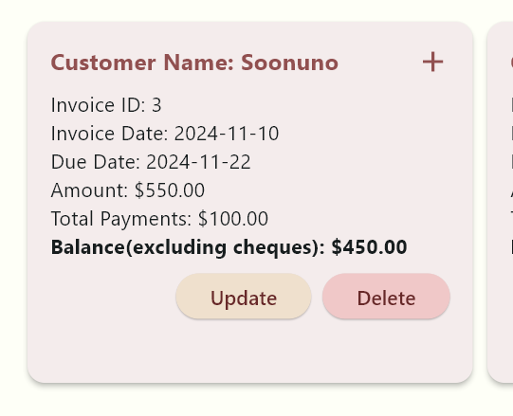

**Balance is changed: 550-100=450**

* **Enter payments (With Cheque):**

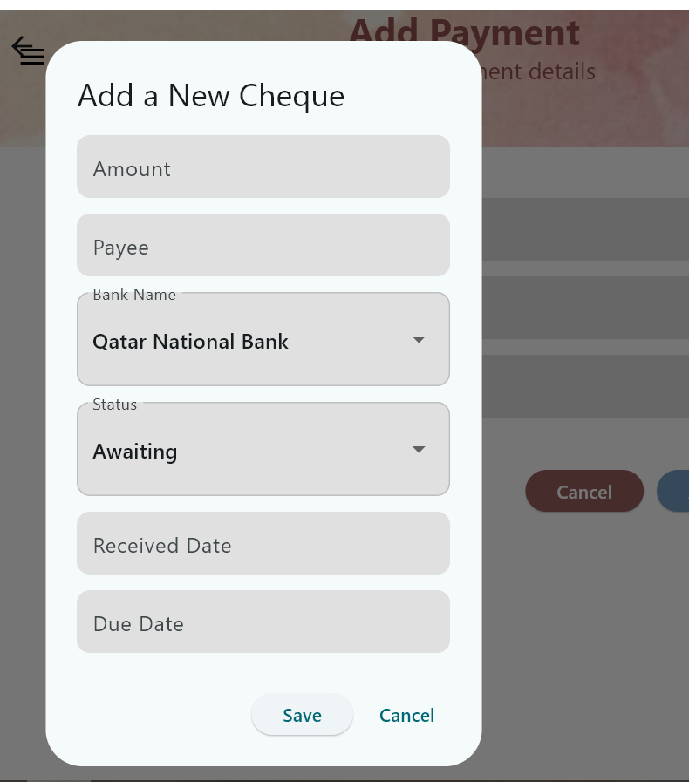

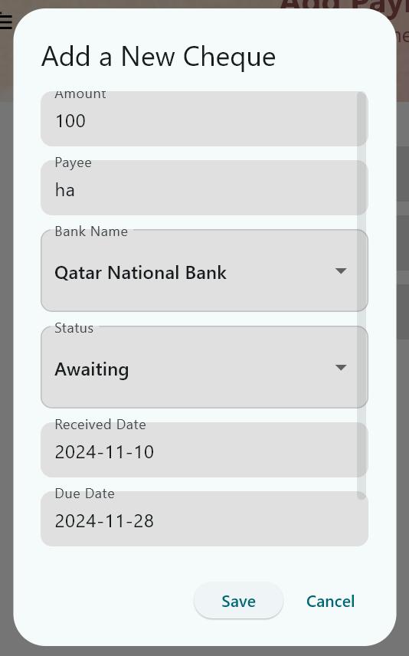

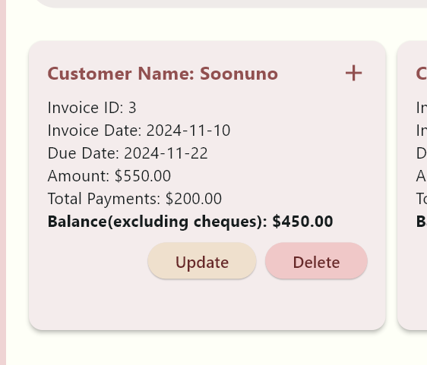

**Total Payments: changed 200, But in Balance Cheque hasn’t been calculated in balance which is what we want.**

# U5 - List/Search/Add/ Update and Delete payments for an invoice

# List Payments

**Payment Screen**

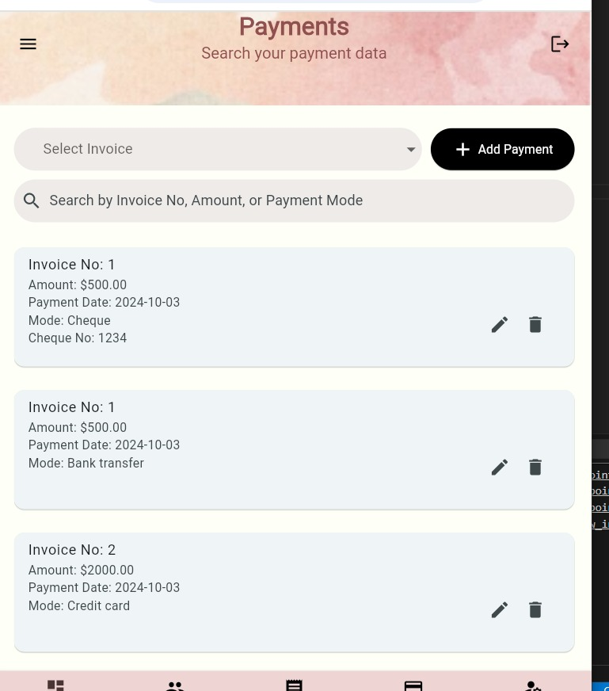

**Searching**

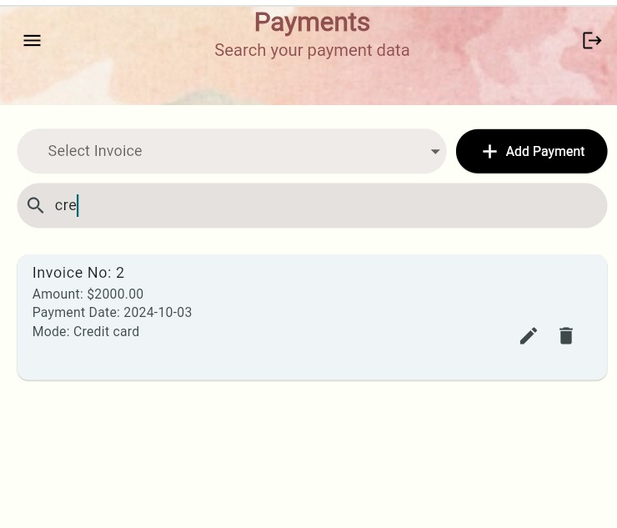

**Add payment only works when you select an invoice**

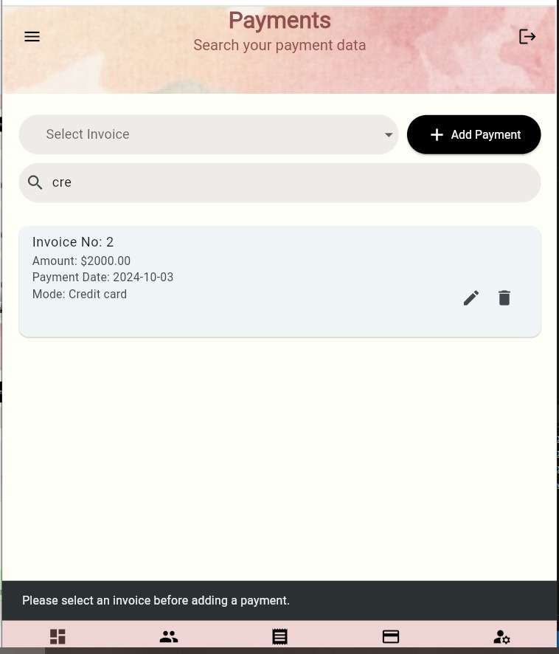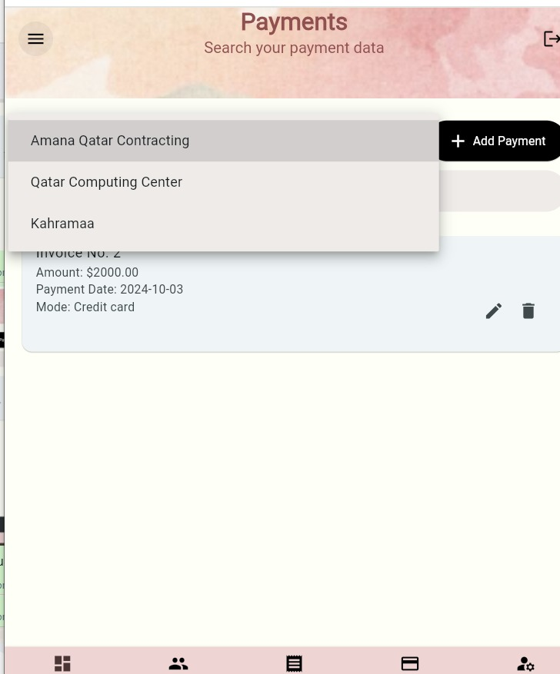

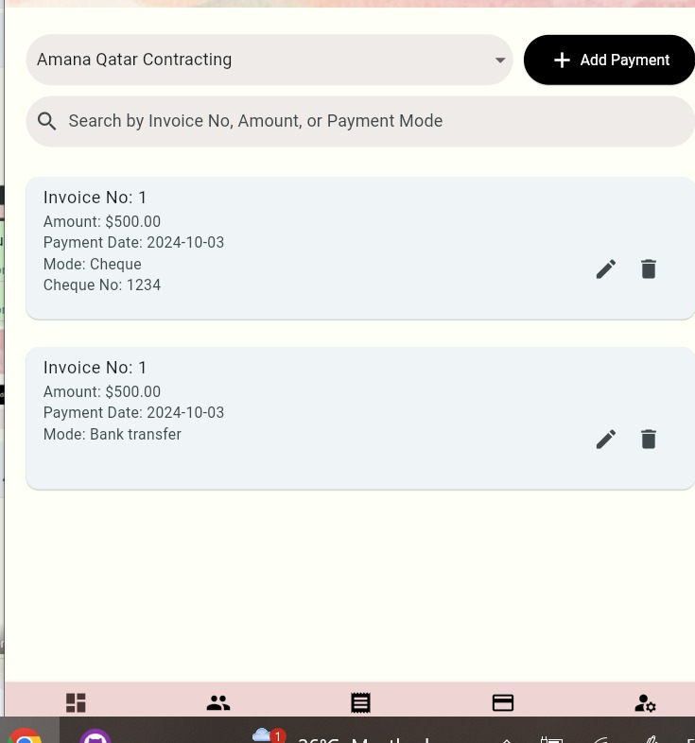

**Deleting an invoice**

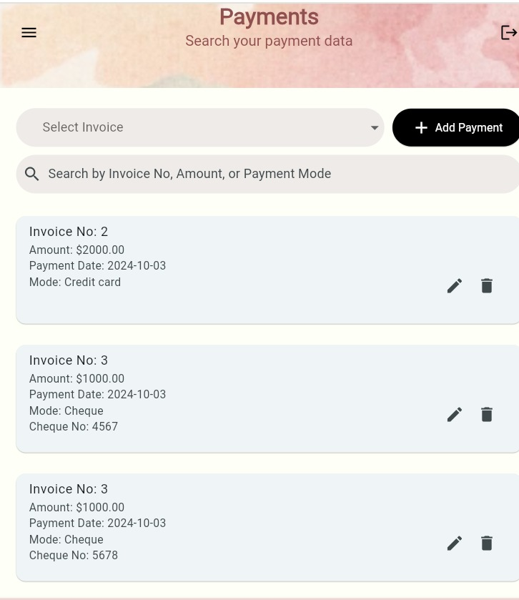

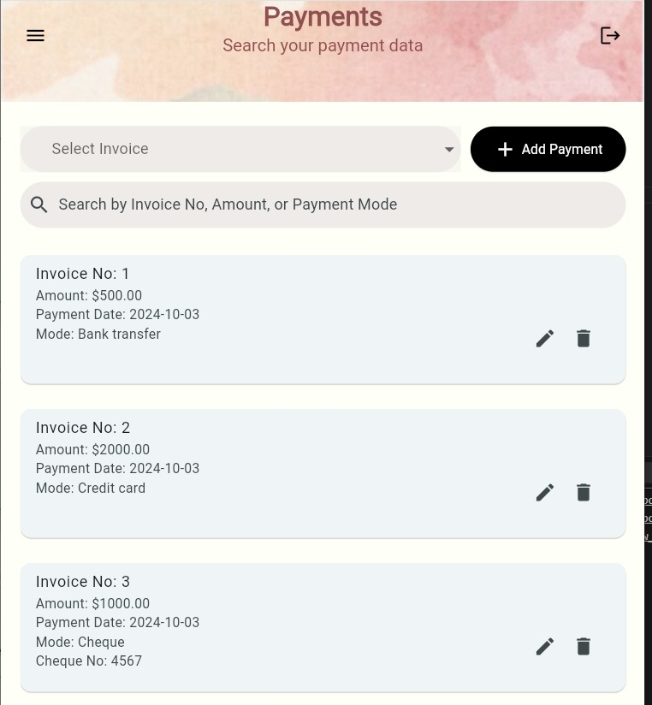

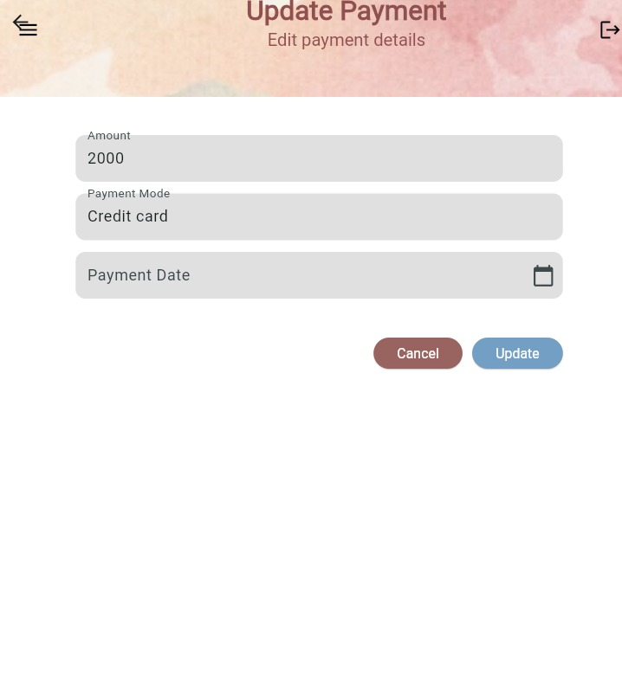

**Update invoice**

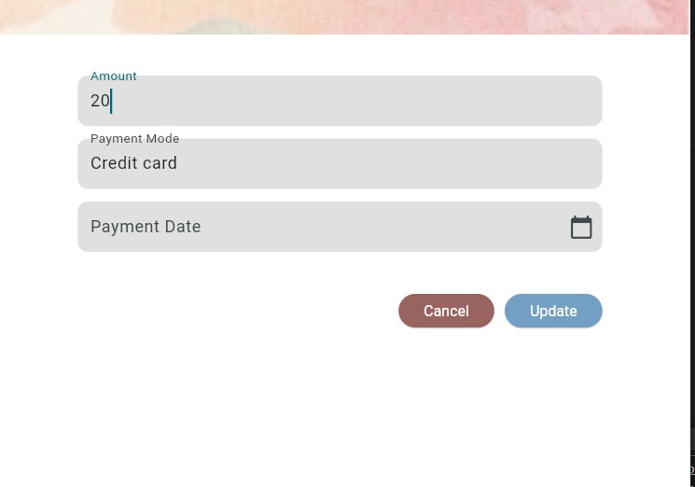

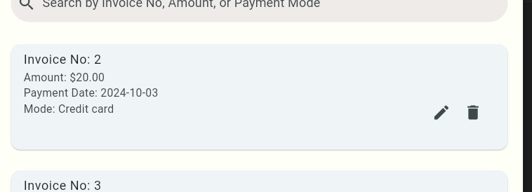

**cheque edit**

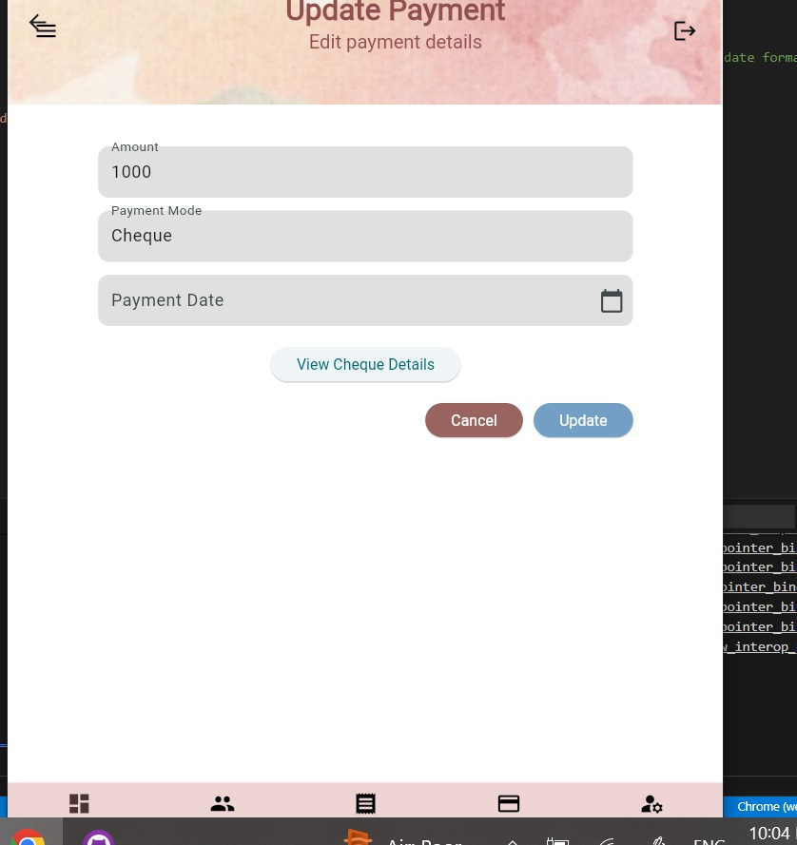

**Save changes**

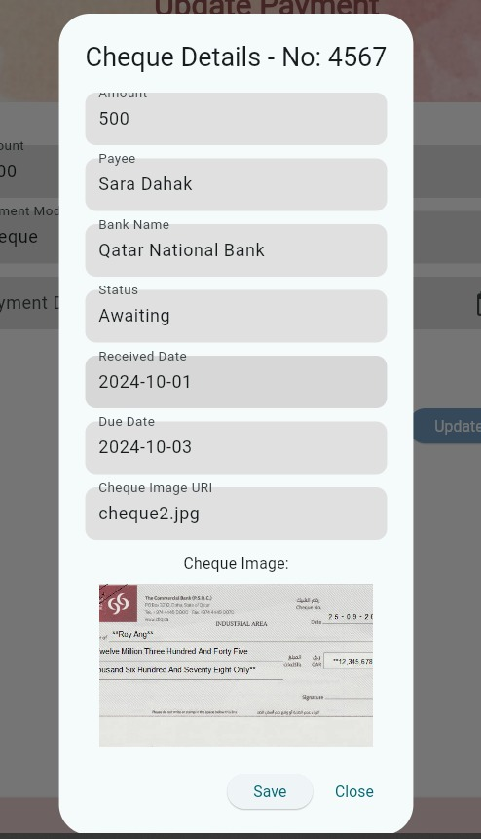

* **Add a Payment**

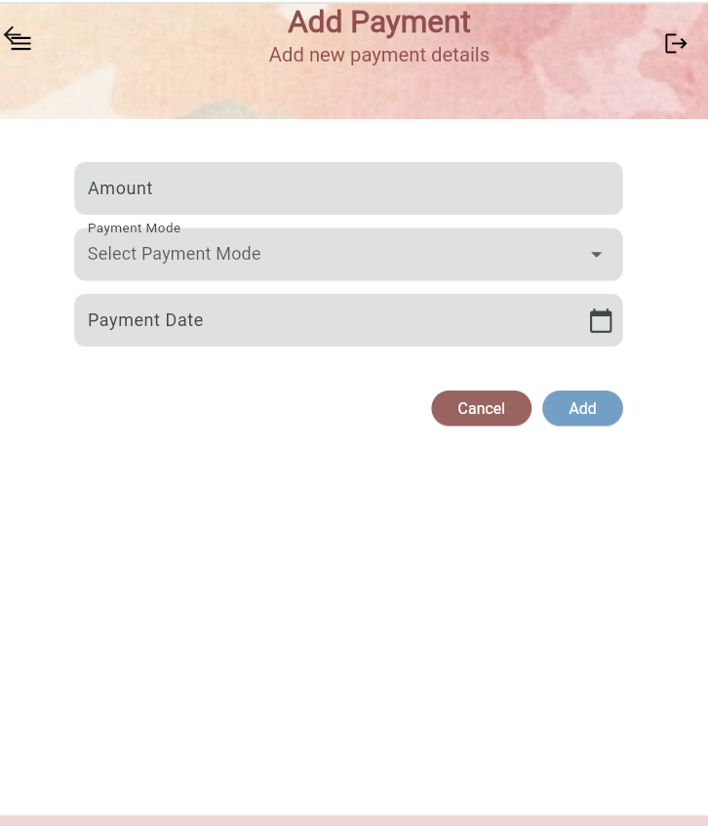

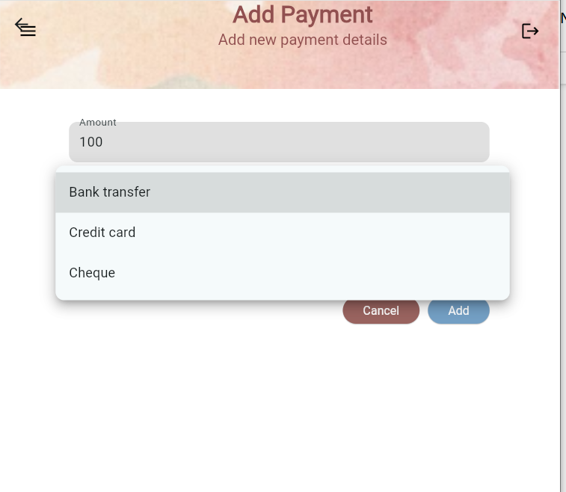

# Search Payments

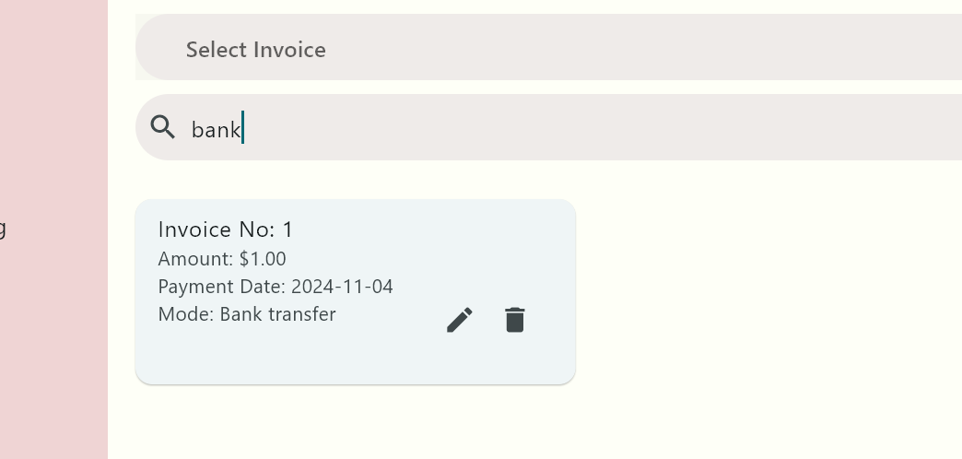

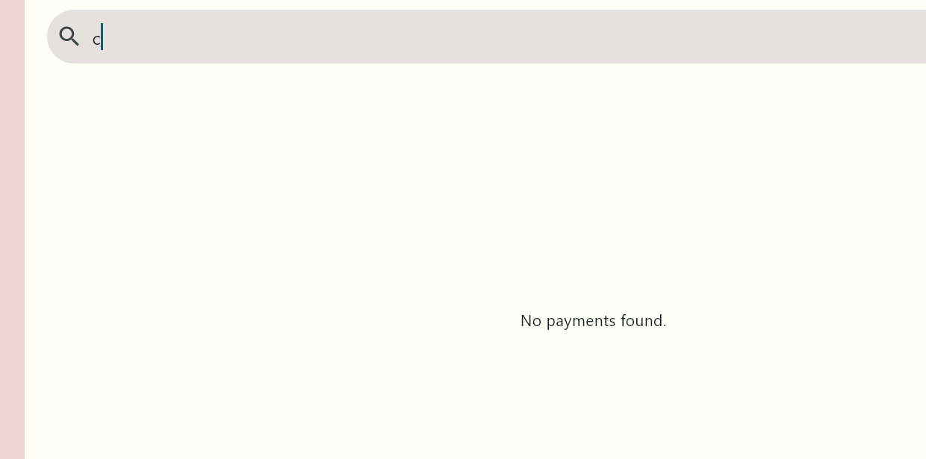

# Add Payment

* 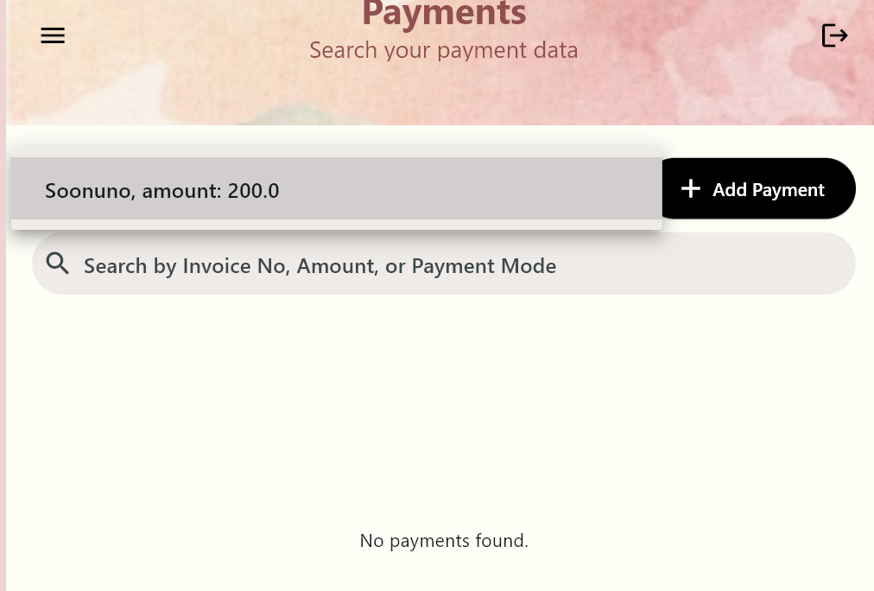
* **For add payment we need to choose which invoice to add to:**
* 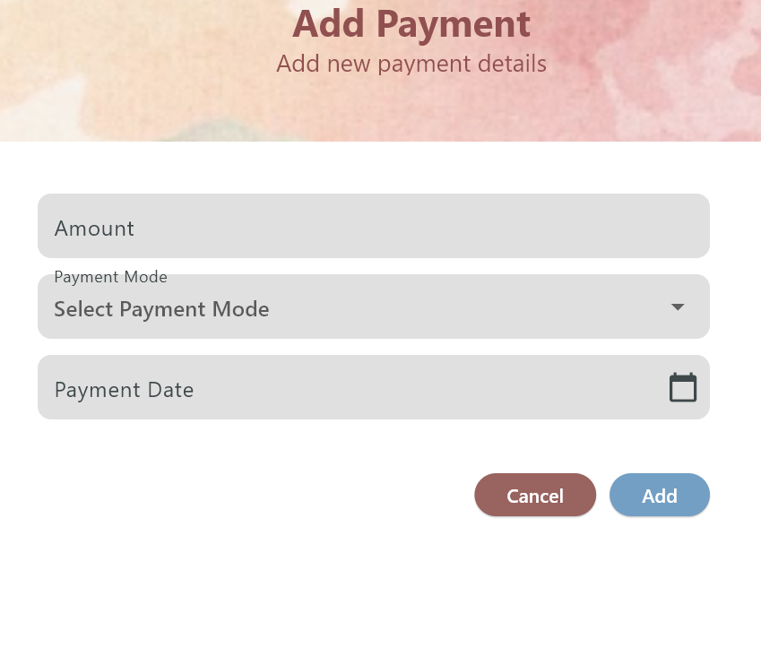
* 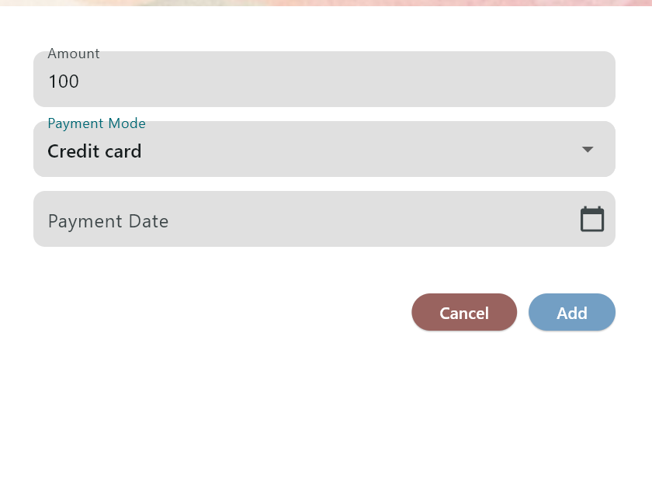

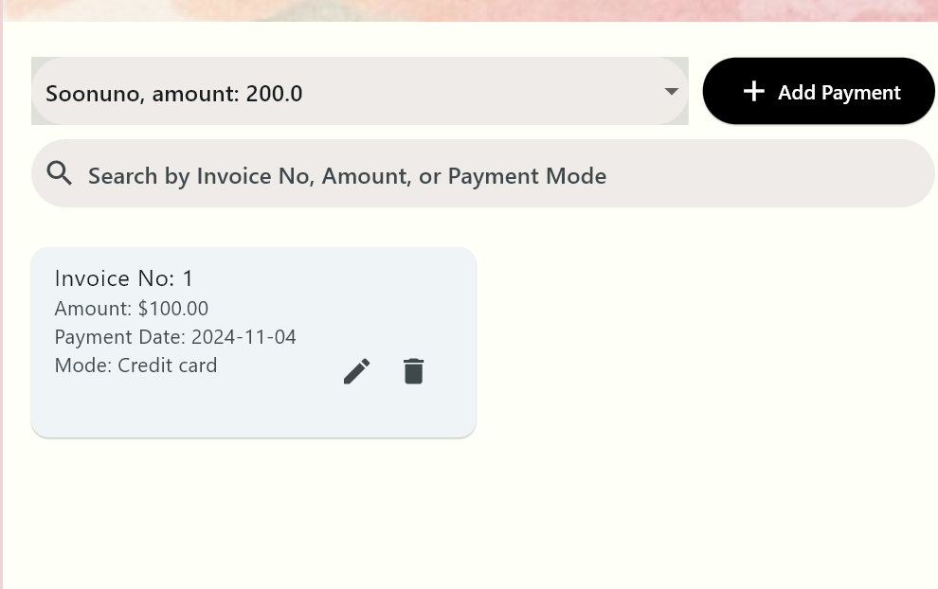

**As a cheque:**

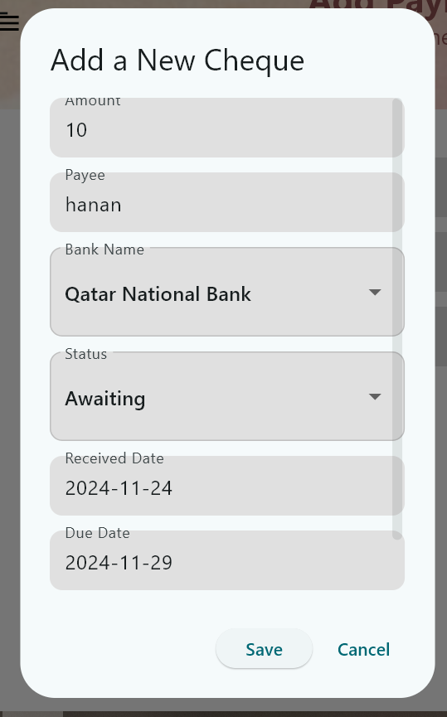

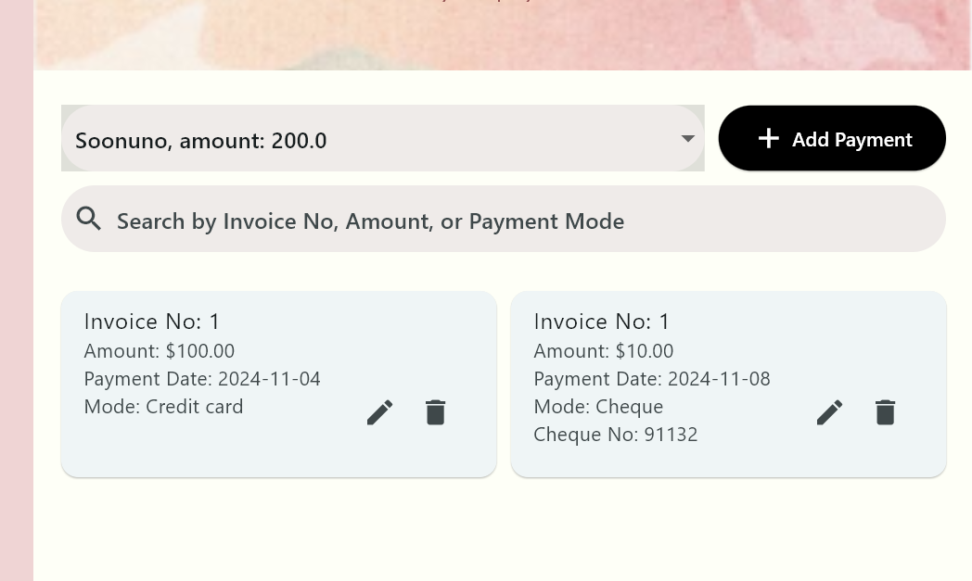

**Cheque number appears.**

* **Edit Payment:**
* 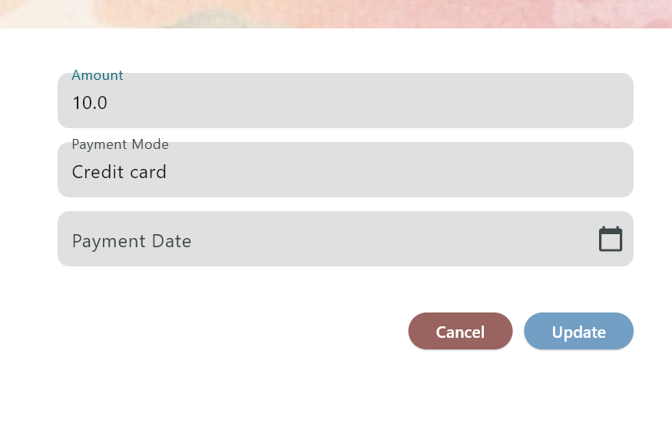
* 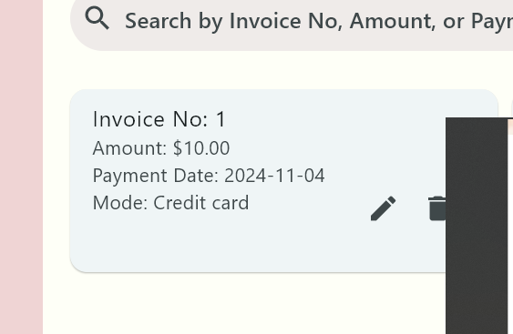

# Update Payment

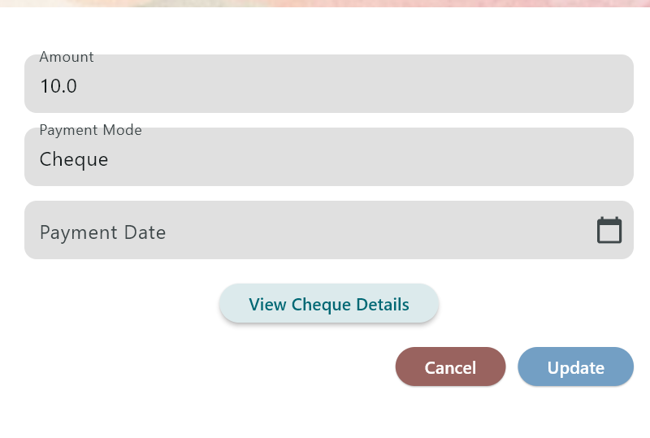

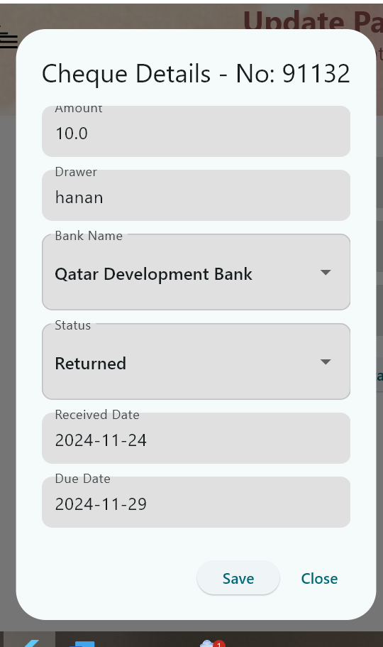

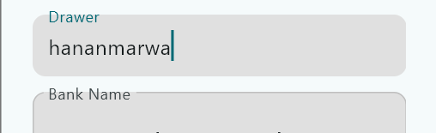

**After re opening view details**

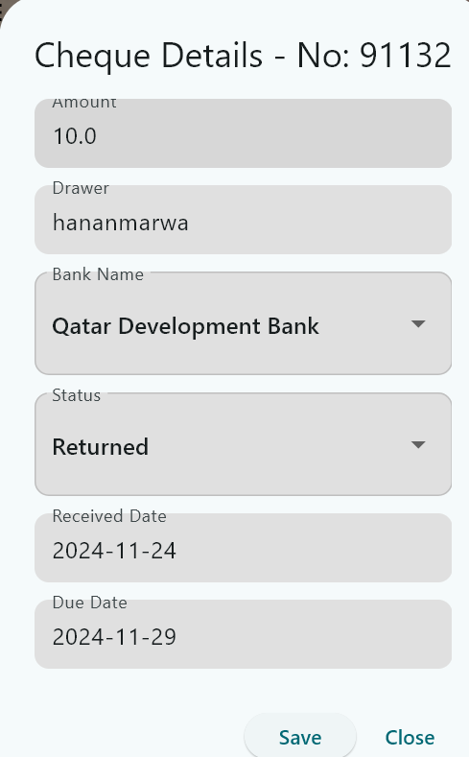

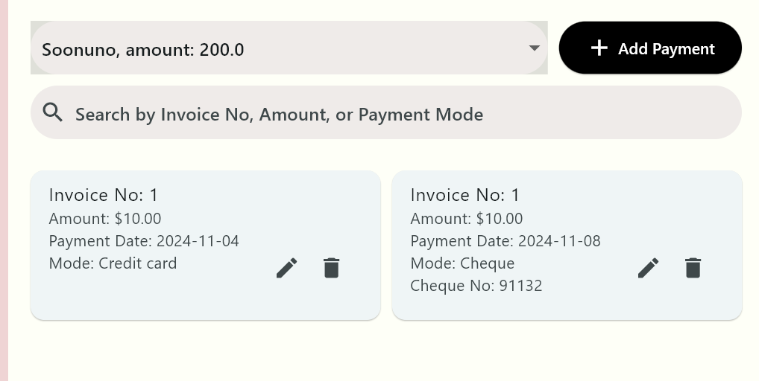

# U6 - Manage Cashing Cheques

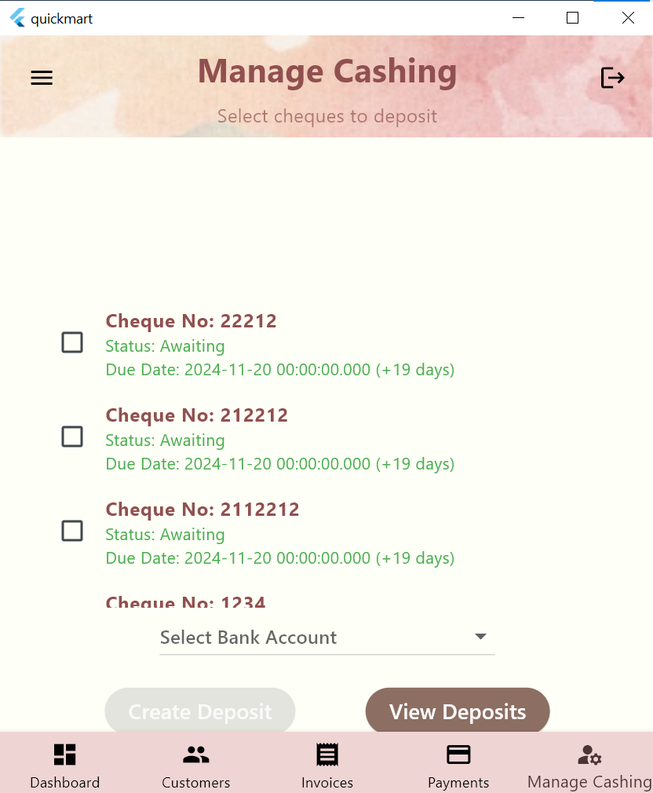

**The cheques no and status and due data are presented and cheques past their due date have their information written in red and the number of days past due are shown**

**You must check or multiple cheques and choose a bank account to deposit to before making a deposit**

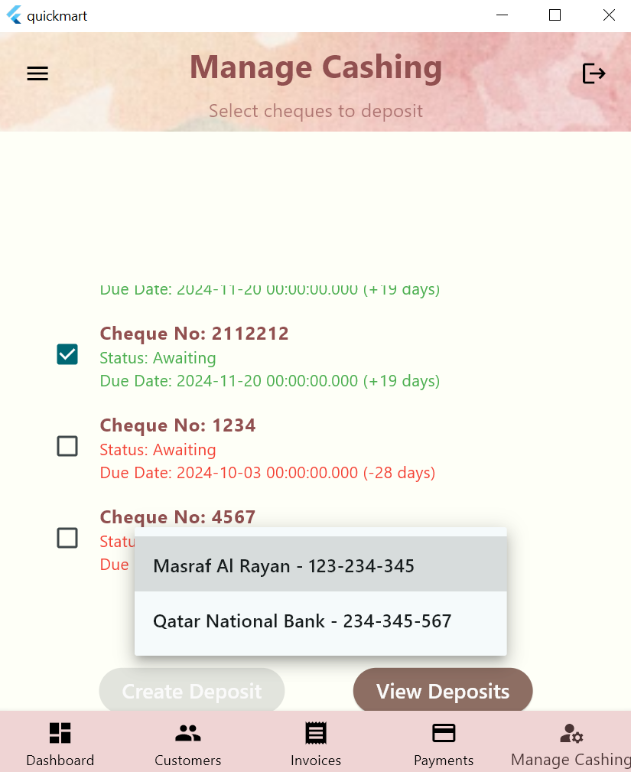

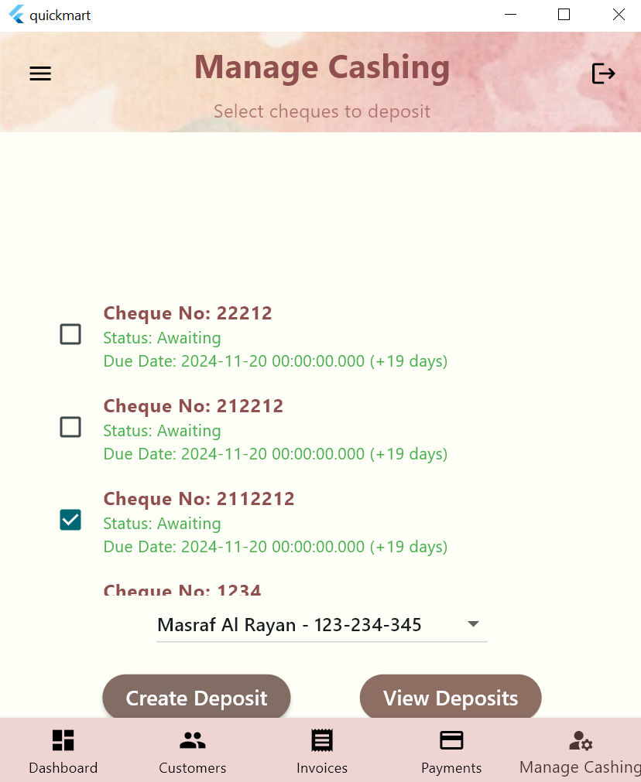

**Deposited cheque is greyed out and u can deposit multiple cheques at the same**

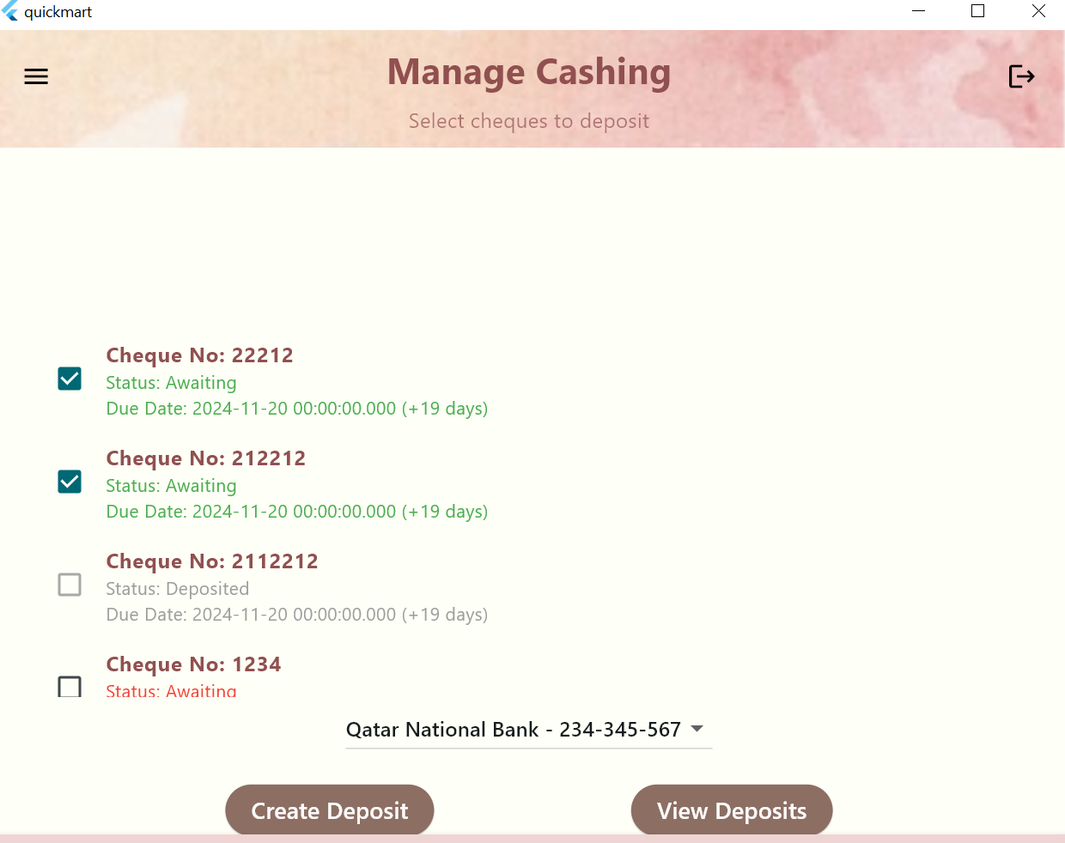

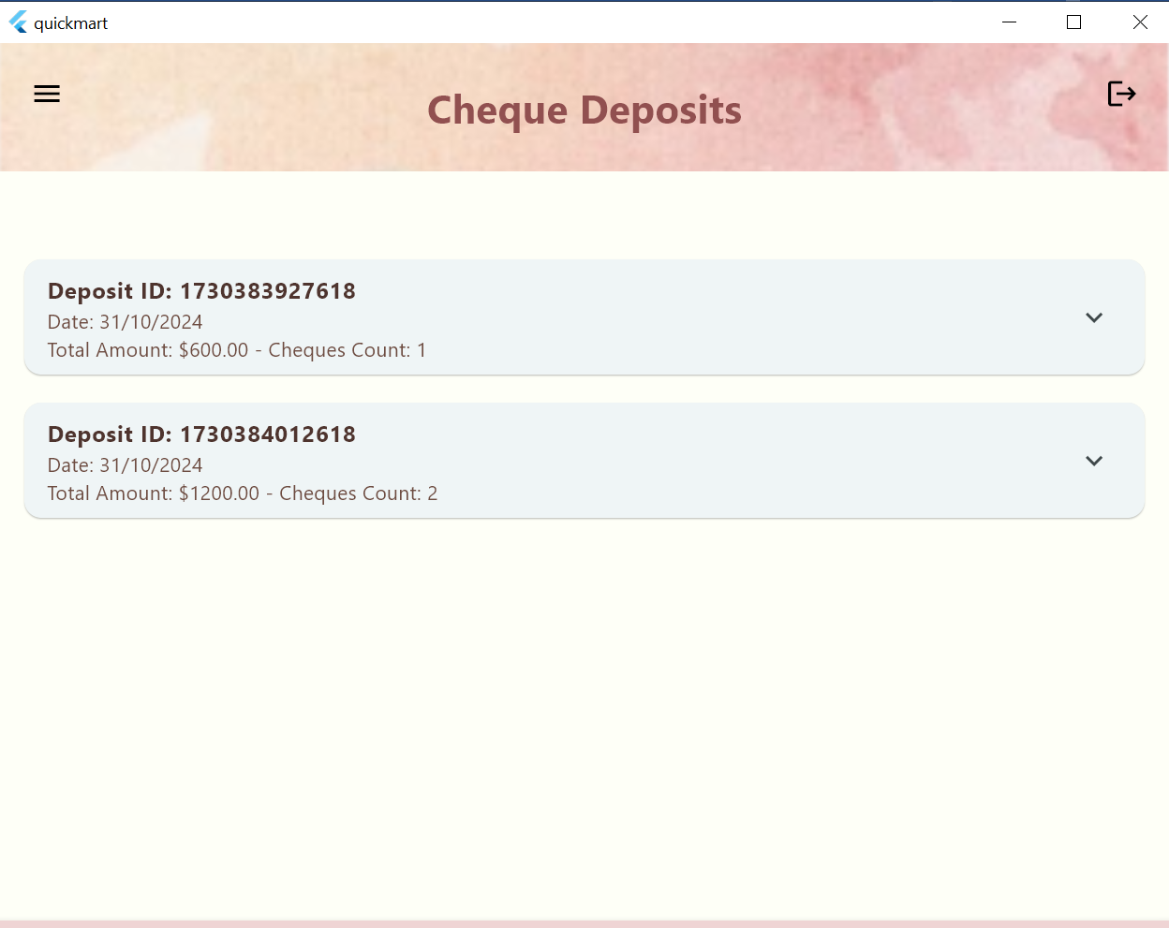

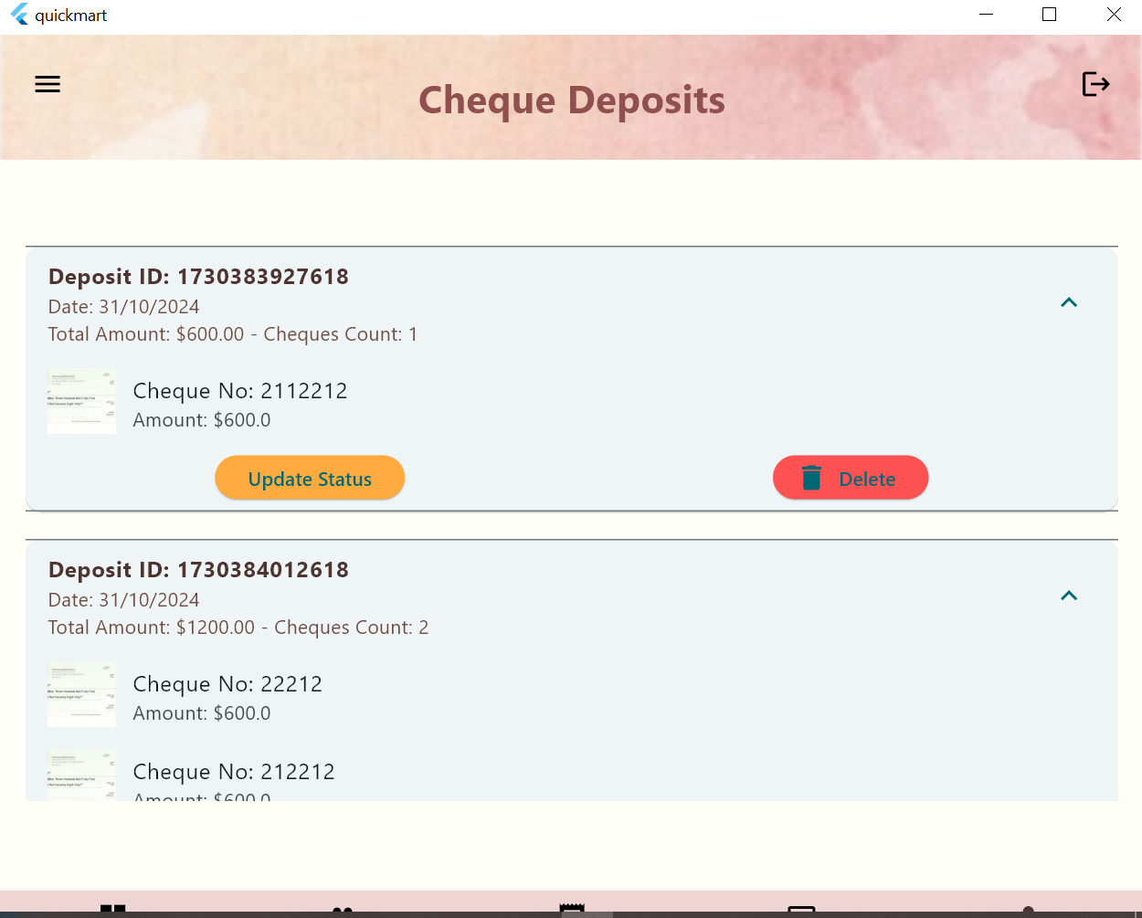

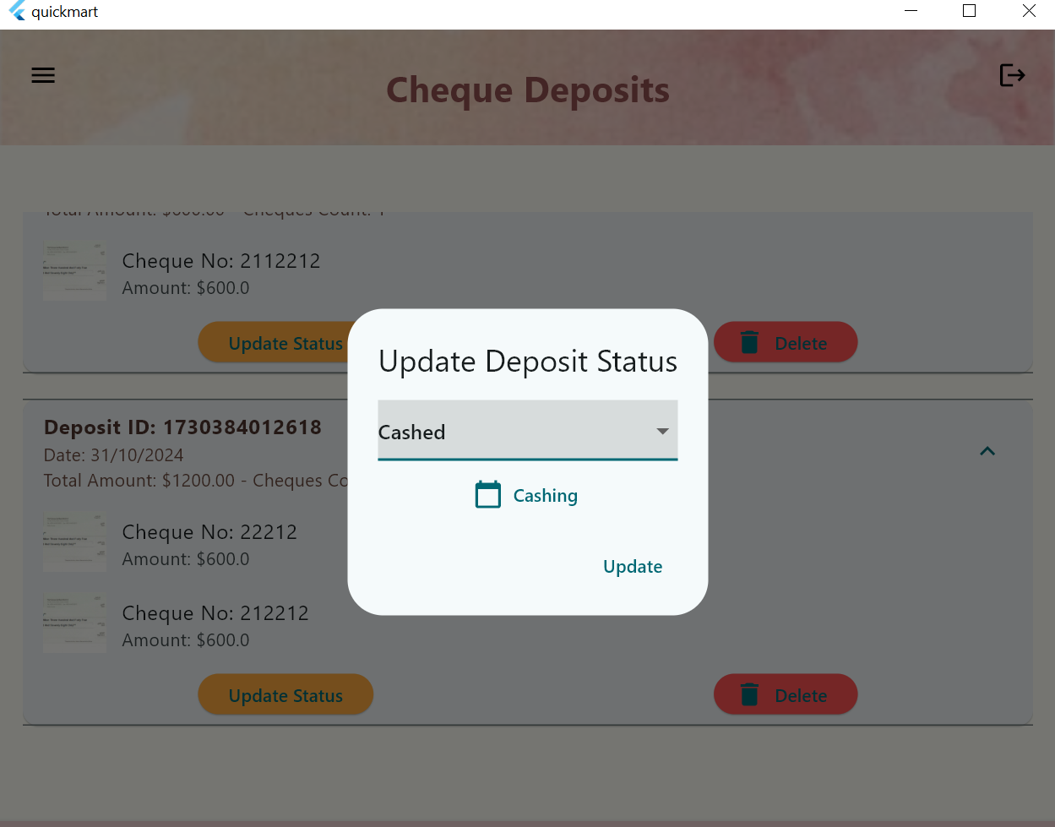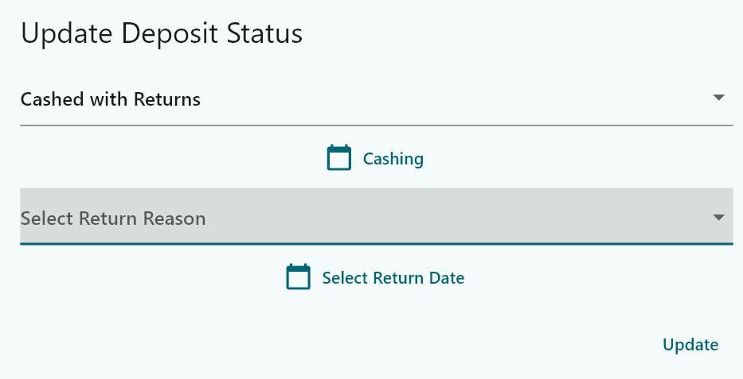

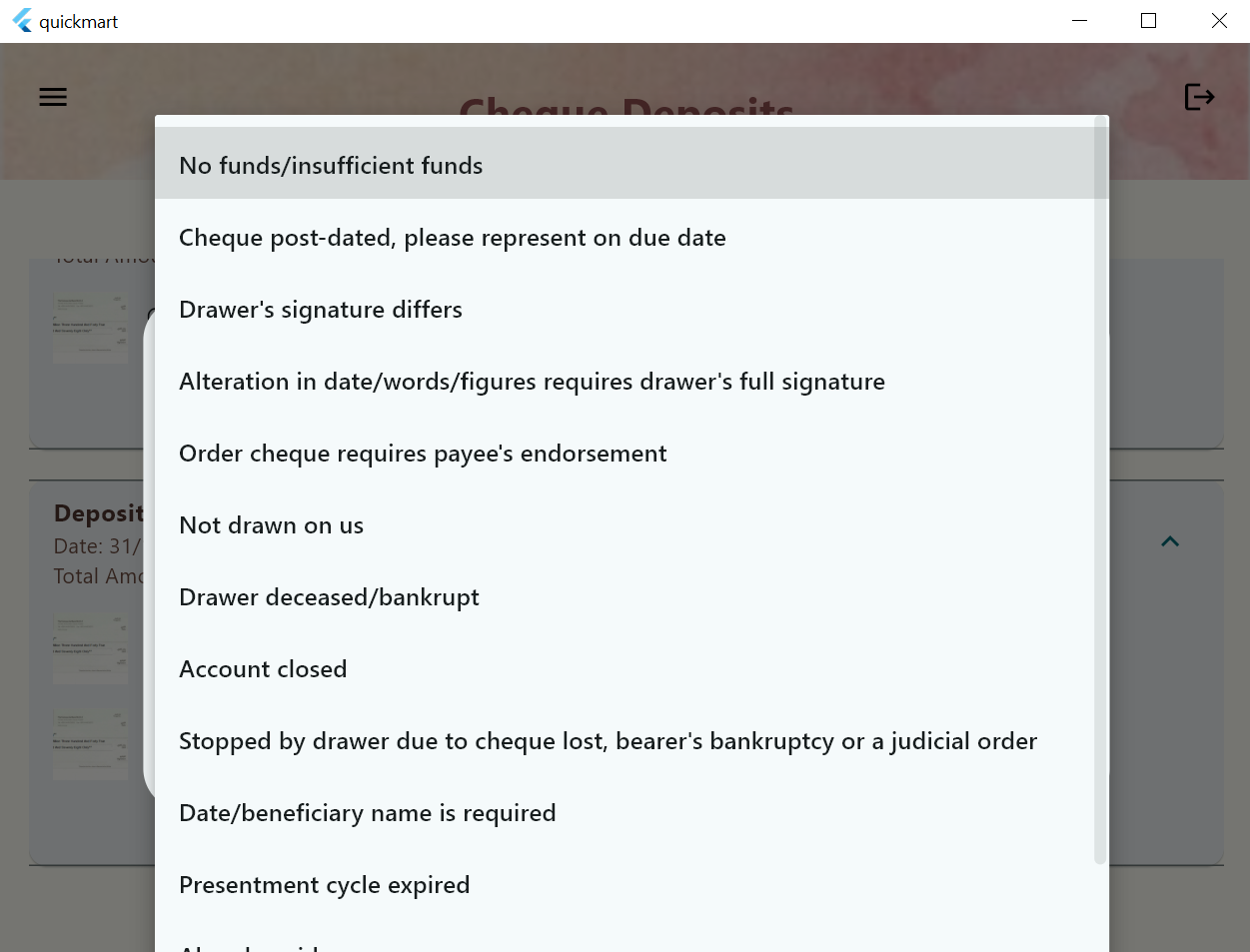

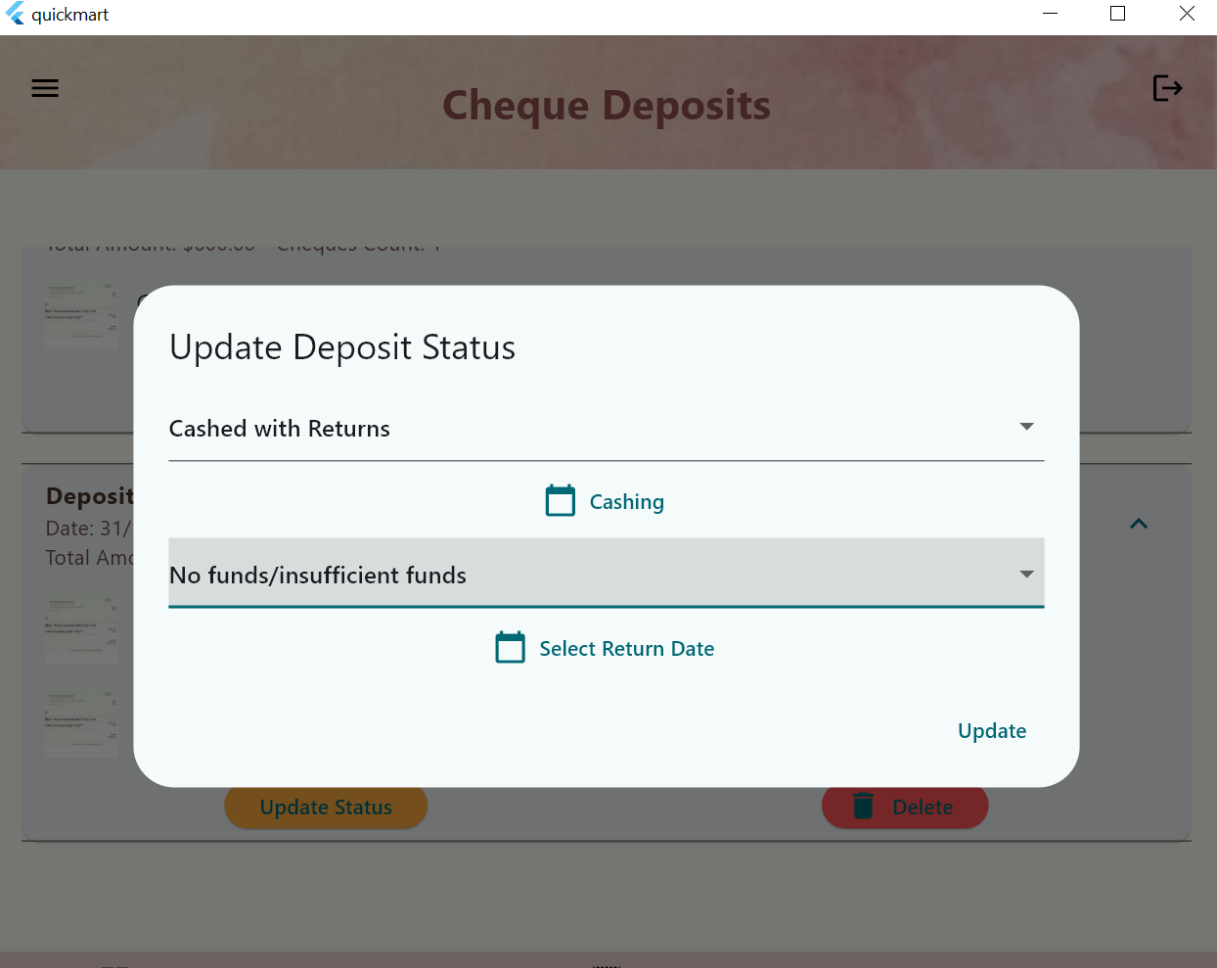

# U7 - Invoices Report

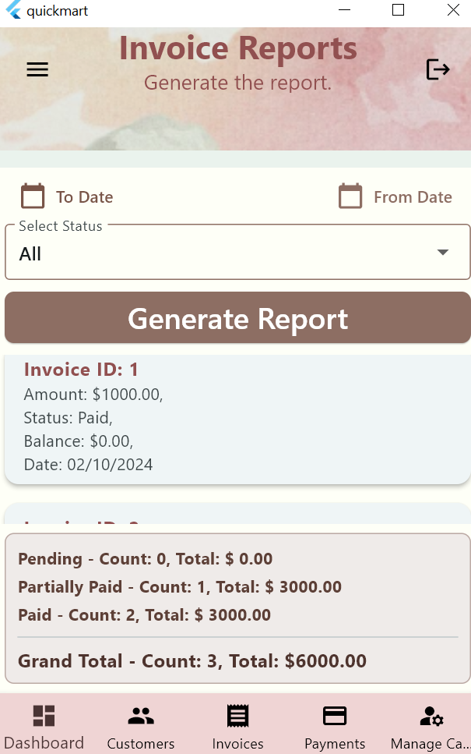

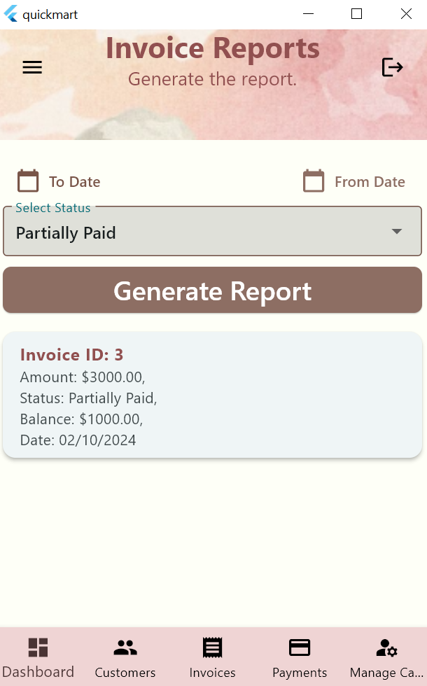

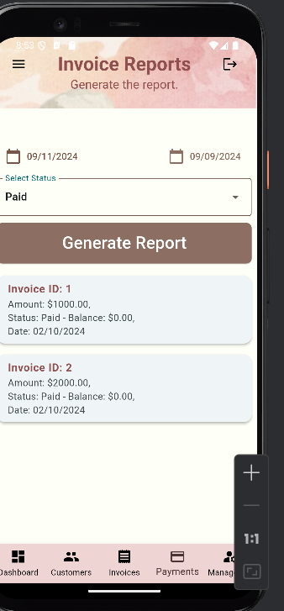

# U8 - Cheques Report

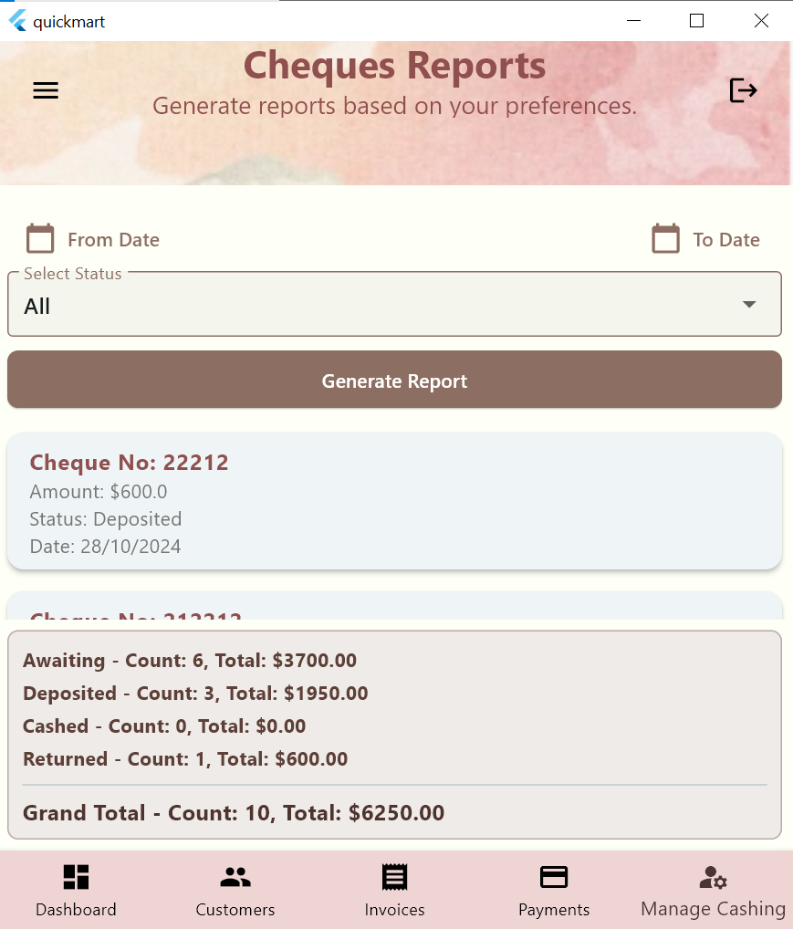

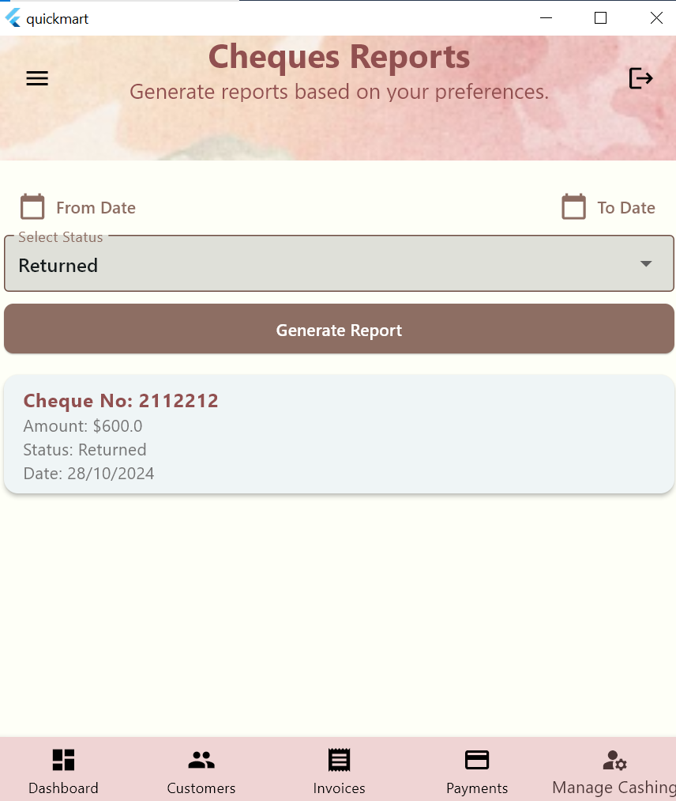

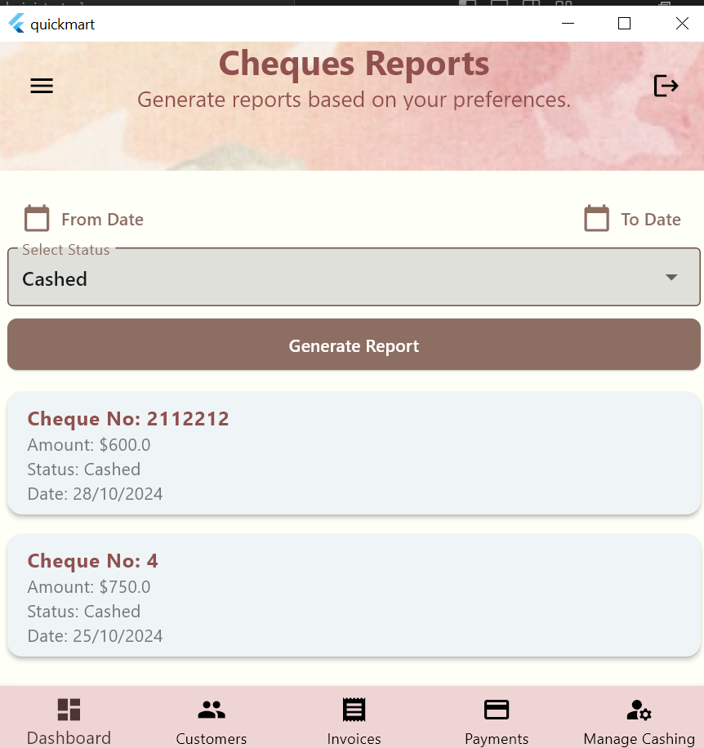

**Filtering using the from date   
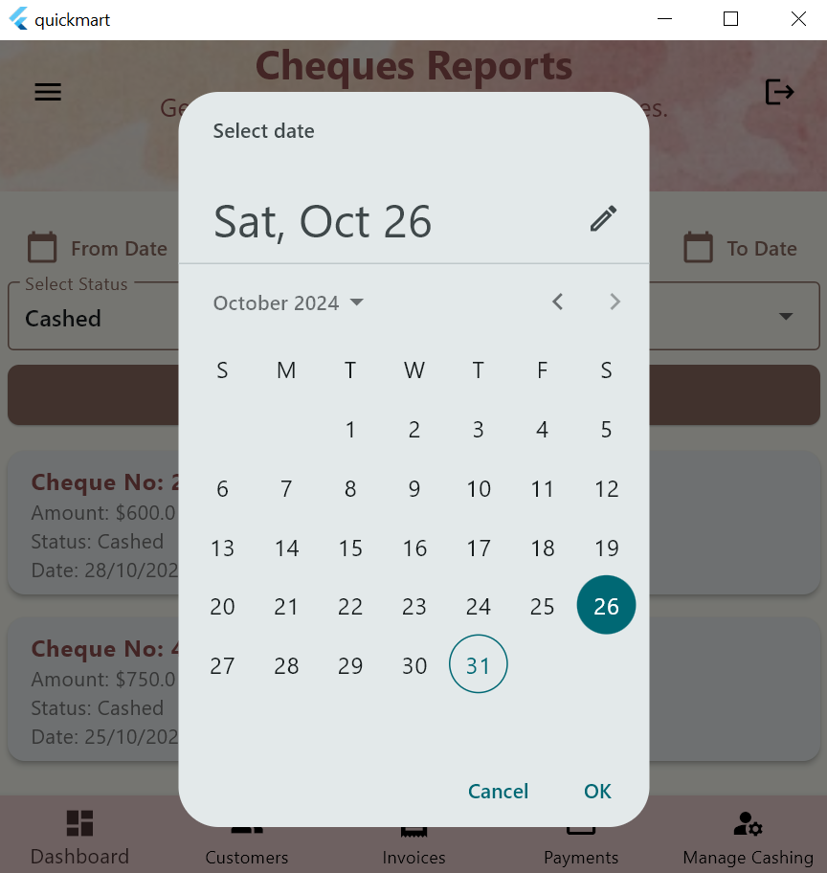**

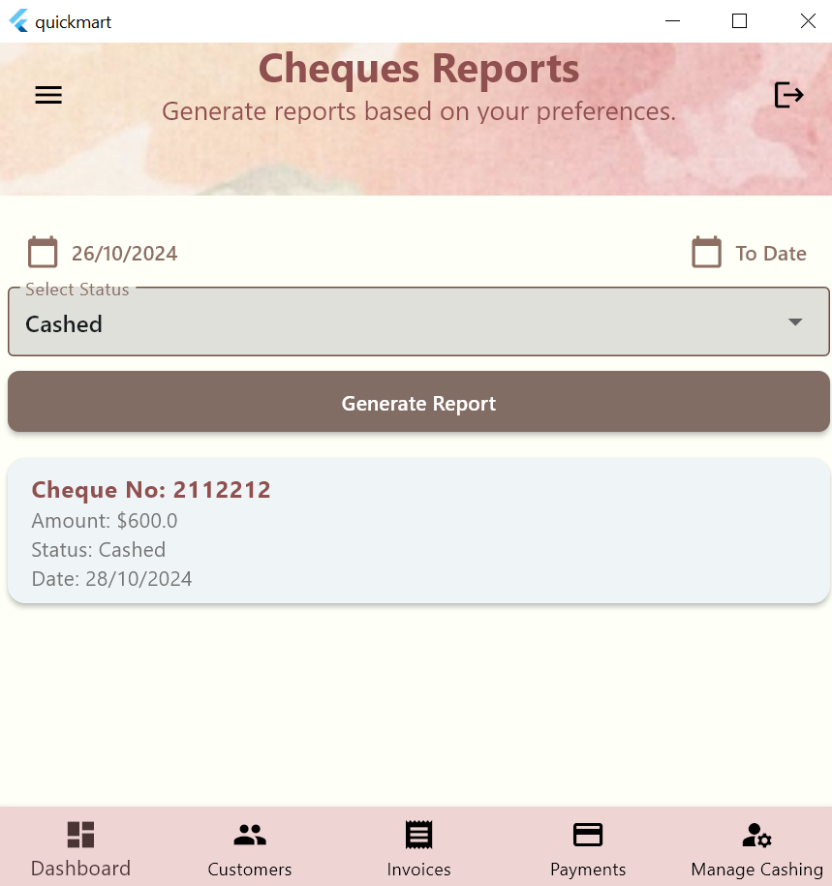

**The delete button deletes the cheque  
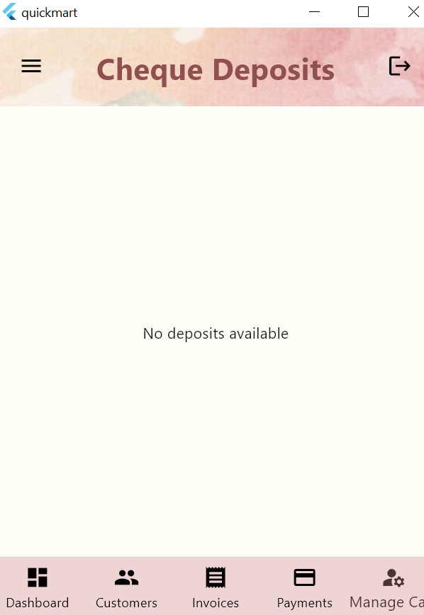**

# Summary of team member contributions

|  |  |
| --- | --- |
| 1. **Member** | **Completed use cases / tasks** |
| **Hanan Rashid** | **35% | usecases: 2,4,5** |
| **Rain Alkai** | **35 | usecases: 6,7,8** |
| **Hanan Alyafei** | **20 | usecases: 1, 3** |
| **Arwa** | **10 | took slight contribution in usecase 7, 5** |

**Description Contribution:**

* **Rain Alkai – 202005090:**

In my work on YalaPay, I contributed to three main use cases: Manage Cashing Cheques (U6), Cheques Report (U8), and Invoices Report (U7). For U6, I developed tools to manage the cheque-cashing process, allowing users to select, deposit, and track cheques, with visual indicators for due dates and functionality to update cheque statuses. In U8 - Cheques Report, I enabled users to filter and view cheque details by date and status, displaying counts and totals for each category. For U7 - Invoices Report, I created a reporting feature where users can filter invoices by period and status, displaying invoice details, pending balances, and overall totals. and financial tracking.

* **Hanan Rashid - 202006354:**

I contributed to the project by designing the UI in Figma and making it fully responsive. I developed the shell screen and set up smooth navigation between screens, incorporating a bottom navigation bar with a drawer for mobile devices and a sidebar for larger screens. I worked on the YalaPay Dashboard (U2), designing it to display invoice and cheque summaries by status using dummy data in phase 1. I also contributed to Invoice Management (U4), enabling the app to list, search, add, update, and delete invoices, including essential details like invoice number, customer ID, and amounts. For Payment Management (U5), I added functionality to manage payments for invoices, allowing users to list, search, add, update, and delete payment records, with special fields for cheque details.

* **Arwa Alobeid - 202102413**

I worked on U5 by helping with the tasks related to payments for invoices. Although I faced some issues with my emulator, which limited my contribution, I was able to create the repository diagram. I worked slightly on U7 Invoices report.

* **Hanan Alyafei - 201808914**

I have worked on the Login, customers use cases and for that I created the following files:

*Under models folder :

address.dart

contact_details.dart

customer.dart

user.dart

*Under providers folder:

customer_provider.dart

user_provider.dart

*Under repo folder:

customers_repository.dart

user_repository.dart

*Under screens folder:

customer_editor_screen.dart

customers_screen.dart

login_screen.dart

*Under widgets folder:

add_customer.dart (add customer button)

customer_card.dart

error_alert.dart

**Overall Contribution:**

In our group project, Hanan Alyafei made a great early contribution by focusing on the login and customer use cases. She did push her work once done, following updates with the group and communicating with Hanan Rashid, in particular, to add any updates or corrections to the code. Hanan Alyafei updates prompted Hanan Rashid to integrate these changes into the codebase actively. This collaborative effort enhanced Hanan Rashid's workload and ensured that the implementation was aligned with the latest design requirements.

Rain also played a key role, working on the report and manage cheque features. Her work was exceptional and greatly enhanced our project.

Hanan Rashid tackled the dashboard and invoices use cases, bringing valuable insights and functionality to the team. Later, Arwa began working on the report invoice and payment use cases. However, she faced some challenges with her UI, which led Hanan Rashid and Rain to step in and complete the tasks for usecase arwa was working on. Their collaboration helped ensure that the majority of the project was finished successfully.

Both Hanan Rashid and Rain demonstrated remarkable dedication and hard work during this phase. They collaborated closely and troubleshooting issues. Their ability to quickly adapt and take on additional responsibilities was essential in keeping the project on track.

Overall, the teamwork and adaptability demonstrated by Hanan Alyafie, Rain, and Hanan Rashid were instrumental in pushing the project forward and overcoming obstacles.